**Superconducting Fault Current Limiter for Energy Storage Protection in a Micro Grid**

J Ranga*,P Satish Kumar**

*\*,** EEE Department,SreeDattha Institute of Engineering & Science*

**Abstract:** This paper presents the protection of energy storage systems (ESSs) with super conducting fault current limiter (SFCL) in micro grid. It is important to supply electrical power to micro grid, the energy storage systems (ESSs) must be interconnected without any interruption. The application of super conducting fault current limiter (SFCL) plays very important role in the reduction abnormal fault current in the micro grid. The main objective of SFCL to keep the ESSs from disconnecting from the grid when the ground fault occurs for this resistive type SFCL model is designed using simulink model and also utilized for determining the an impendence level of the SFCL according to the fault current limitation. The simulation results are obtained using MATLAB/SIMULINK software.

***Index terms*:** *Energy storage, fault current, super conducting fault current limiter*

1. **INTRODUCTION**

In recent years, more energy storage systems (ESSs) have been interconnected with the power grid An ESS enables energy to be stored when there is an excess of supply and supplies excess energy to loads to compensate for a deficit in supply.The main objective of this paper is to review the technologies used for energy storage in protection in micro grid and to present the latest advance and developments at the component and system level as well as to discuss some implementation issues. The application of super-conducting fault current limiters (SFCLs) to an ESSs for a stable operation of the distribution system has been recognized as one of the promising solutions for fault current problems, because of its fast fault current limiting and automatic characteristics of recovery.

The devices in electronics and electrical circuits are sensitive to disturbance and any disturbance or fault may damage the device permanently so that it must be replaced. The cost of equipment like circuit breakers and transformers in power grids is very expensive. Moreover, replacing damaged equipment is a time and labour consuming process, which also affects the reliability of power systems. It is not possible completely eliminate the faults but it is possible to limit the current during fault in order to save the equipment and devices in the circuits or systems. Superconducting Fault Current Limiter (SFCL) is optimal equipment which has the capability to reduce fault current level in power system.

The effect of an SFCL applied to an ESS is analyzed. A resistive SFCL is described in Section II. Section III describes the effects of fault current limiting. Section IV describes the effect of SFCL on LG fault. Finally, the conclusions are presented in Section V.

1. **SUPERCONDUCTING FAULT CURRENT LIMITER**

A fault current limiter fundamentally, offers a very high impedance to fault current, bringing it down to a low level, in a very short time. The SCFCL will be in superconducting state (zero resistance) during normal operation and transits to normal state (high impedance) during fault conditions. The SCFCLs have distinct advantages over conventional FCLs in high voltage networks. SCFCL provides an ultra-fast transition from superconducting to normal state and is self-operating and repetitive in nature. Further, during normal operation the resistance being zero, the losses will be negligibly small. At present, the superconducting fault current limiter (SCFCL) applications are mostly concentrated in ac systems.

Their application in dc systems has not received much attention. One of the major difficulties in the application of SCFCL is the losses in the leads. The dc network will need only two current leads, as against six for 3 phase ac system. These losses, in case of dc operation, are almost zero. Thus dc SCFCLs would require a refrigeration system of much lower power. In fact, this would make them more compact and less expensive. Operationally, ac and dc SCFCLs differ in terms of limitation period, which is substantially larger in case of dc. On the other hand, the peak current immediately after the occurrence of the fault, known as the quench current and resistance increase of the SCFCL are expected to remain the same fundamentally, for both ac to dc networks.

Superconducting Fault Current Limiter (SFCL) is innovative electric equipment which has the capability to reduce the fault current level within the first cycle of fault current. The first-cycle suppression of fault current by a SFCL results in an increased transient stability of the power system carrying higher power with greater stability. The concept of using the superconductors to carry electric power and to limit peak currents has been around since the discovery of superconductors and the realization that they possess highly non-linear properties. More specifically, the current limiting behavior depends on their nonlinear response to temperature, current and magnetic field variations. Increasing any of these three parameters can cause a transition between the superconducting and the normal conducting regime. The current increase can cause a section of superconductor to become so resistive that the heat generated cannot be removed locally. This excess heat is transferred along the conductor, causing the temperature of adjacent sections to increase. The combined current and temperature can cause these regions to become normal and also generate heat.

**Simulation Model of SFCL**

The SFCL model enveloped in Simulink/SimPower System is shown in Figure.1. The parameters for the R-SFCL model and their selected values are: 1) Transition or response time = 2msec 2) Minimum impedance = 0.01Ω. Maximum impedance = 20Ω 3) Triggering current = 550A and 4) Recovery time = 10msec. The SFCL working voltage is 22.9kV. The Simulink model was compose of four major parts: 1. RMS value 2.Characteristic table of SFCL 3.Harmonic Filtration 4. Voltage controlled oscillator (VCO). The SFCL model works as follows. First, SFCL model calculates the RMS value of the passing current and then compares it with the characteristic table. Second, if a passing current is larger than the triggering current level, SFCLs resistance increases to maximum impedance level in a pre-defined response time. Finally, when the current level falls below the triggering current level the system waits until the Recovery time and then goes into normal state. The SFCL characteristic table shown in Figure 2 plays a main role which consists of standard parameter values of SFCL. The current limiting resistance value is calculated and this value is implemented in the simulation model. The important parameter to be given in SFCL is the current limiting resistance value. In order to avoid harmonics caused by transients, filter is used.

1. **MODELING OF A MICRO GRID WITH AN ENERGY STORAGE SYSTEM**

*Resistive SFCL Model*

Resistive SFCLs utilize the superconducting material as the main current carrying conductor under normal grid operation. The principle of their operation is



**Fig. 1 :** Simulink model of single phase SFCL

shown in the one-line diagram of Figure 1-1.As mentioned above, the figure1 is a normalized plot of voltage across RSC as a function of the ratio of current through the device, Iline, to the “critical current”, IC, of the superconducting element. At present, for HTS materials, the convention is to define “critical current” as the current at which a voltage drop of 1.0 μ V/cm is observed along the conductor. When a fault occurs, the current increases and causes the superconductor to quench thereby increasing its resistance exponentially.



**Fig1.1:** Resistive Type SFCL with Shunt Element

The current level at which the quench occurs is determined by the operating temperature, and the amount and type of superconductor. The rapid increase in resistance produces a voltage across the superconductor and causes the current to transfer to a shunt, which is a combined inductor and resistor. The shunt limits the voltage increase across the superconductor during a quench. In essence, the superconductor acts like a switch with millisecond response that initiates the transition of the load current to the shunt impedance. Ideally, the incipient fault current is limited in less than one cycle. The grid characteristic of the resistive SFCL after a quench is determined by the shunt element.



**Fig1.2:** and a normalized plot of voltage and current in a superconductor at a constant temperature and magnetic field

Thus, because the shunt is typically quite reactive, a resistive SFCL typically introduces significant inductance into the power system during a fault. During the transition period when current is being transferred from the superconductor to the shunt, the voltage across the combined element shown in Fig 1-2 is typically higher than it is after the current has transitioned into the shunt. The dynamics of this process depend on the two elements and their mutual inductance. Some resistive SFCLs include a fast switching component in series with the superconducting element. This switch quickly isolates the superconductor after most of the current has transitioned to the shunt element, allowing the superconducting element to begin the recovery cycle while the limiting action is sustained by the shunt. The fast-acting switch reduces the peak temperature within the superconductive material and allows for faster recovery times than for purely resistive SFCLs. This type of SCFL is sometimes referred to as a *hybrid SFCL.*

1. **CASE STUDY**

To evaluate the effect of the SFCL on a single line-to-ground fault in the distribution system with an ESS, simulations were performed with the existence of an SFCL and modeled using PSCAD/EMTDC software.

***A. Case 1: Single Line-to-Ground Fault Without an SFCL***

The effect of the ESS interconnecting transformer without an SFCL on a single line-to-ground fault is analyzed in case 1. Fig. 2 shows how the ESS interconnection, which is not applied to an SFCL, contributes to a single line-to-ground fault in a distribution system. The red arrows (*I*g *,*Mtr*.* And *I*g*,*feeder2) illustrate the path of the fault currents from the substation and the ESS interconnecting transformer electrical grounds to a fault location. It flows back through the solidly grounded substation transformer and contributes additional current flow to the fault location. The magnitude of fault current depends on the size and impedance of the interconnecting transformer. On the delta side of the interconnecting transformer,

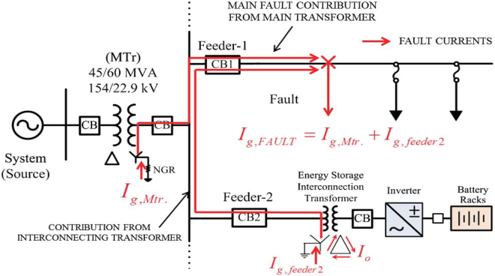

**Fig. 2.** Effect of a single line-to-ground fault on an ESS interconnecting transformer without an SFCL

no zero-sequence currents appear in the lines, though these currents (I0) circulate in the delta windings to balance the ampere turns in the wye windings [9], [19]. The fault current is primarily designed to flow through the electrical ground of the main transformer and not the electrical ground of the interconnecting transformer.

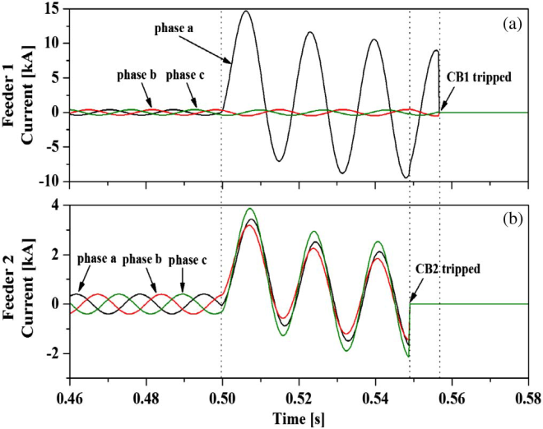

**Fig. 3.** Feeder currents caused by the single line-to-ground fault in feeder-1 without an SFCL applied to the interconnecting transformer: (a) feeder-1 currents at CB1 and (b) feeder-2 currents at CB2

The ESS that is interfaced with the power system creates a new path for a zero-sequence current flowing a fault current or a zero-sequence current. Fig. 3 shows the feeder currents caused by the single line to- ground fault in feeder-1 without an SFCL application to the ESS interconnecting transformer. The single line-to-ground fault is simulated at 0.5 s in phase for feeder-1. The fault current trips CB1 as well as CB2, which is tripped by a zero-sequence current fed from the electrical ground of the interconnecting transformer. This means that the ESS is inevitably disconnected from the power system whenever a ground fault occurs. The currents in feeder-2 fed from the ESS increase after a ground fault, as shown Fig.3.This is because the zero-sequence current injected from the electrical ground of the ESS interconnecting transformer is evenly distributed to each phase current in the transformer. Fig.4.describes the relationship between the zero-sequence current and each phase current.

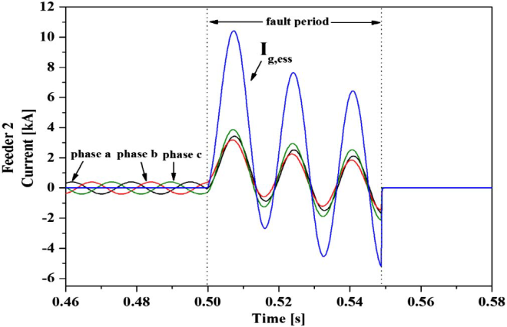

**Fig. 4.** Phase currents in feeder-2 and the zero-sequence current to the electrical ground of the ESS interconnecting transformer

***B. Case 2: Single Line-to-Ground Fault With an SFCL***

The effect of the ESS interconnecting transformer with an SFCL on a single line-to-ground fault is analyzed in case 2. In Fig. 5, the red arrows (*I*g*,*Mtr*.* and *I*g*,*feeder2) illustrate the path of the fault current from the substation and the ESS interconnecting transformer ground. The fault current flowing through feeder-2 and CB2 is reduced by an 8-Ω SFCL applied to the interconnecting transformer and is not enough to trip CB2. Despite a single line-to ground fault, it is not allowed to disconnect the ESS from the power system, as shown in Fig. 6.



**Fig. 5.** Effect of a single line-to-ground fault on the ESS interconnecting transformer with an SFCL.

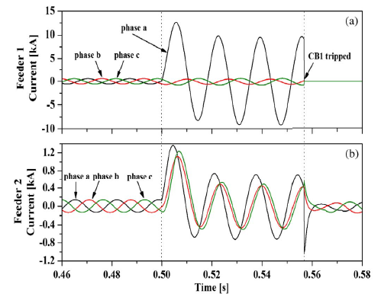

**Fig. 6.** Feeder currents caused by a single line-to-ground fault on feeder-1with an SFCL applied to the interconnecting transformer: (a) feeder-1 currents at CB1 and (b) feeder-2 currents at CB2.

1. **CONCLUSION**

Hence we analyzed the effect of the presence of an SFCL on energy storage system(ESSs) The application of superconducting fault current limiters (SFCL) for smart grid is reduction of abnormal fault current and the protection of Energy storage systems (ESSs) in micro grid. Also multiple SFCLs in micro grid are inefficient both in performance and cost. Super conducting fault current limiter (SFCL) is innovative electric equipment which has the capability to limit fault current within first cycle. The first cycle suppression of fault current by SFCL results in an increased transient stability of power system carrying higher power with greater stability.

**REFERENCES**

1. G. Coppez, S. Chowdhury, and S. P. Chowdhurry, “Impacts of energy storage in distributed power generation: A review,” in *Proc. Int. Conf. Power Syst. Technol.*, Oct. 2010, pp. 1–7.
2. A. Oudalov, T. Buehler, and D. Chartouni, “Utility scale applications of energy storage,” in *Proc. IEEE ENERGY Conf.*, Atlanta, GA, Nov. 17–19, 2008, pp. 1–7.
3. J. A. Carr, J. C. Balda, and J. A. Mantooth, “A survey of systems to integrate distributed energy resources and energy storage on the utility grid,” in *Proc. IEEE ENERGY Conf.*, Atlanta, GA, Nov. 17–19, 2008, pp. 1–7.
4. A. Mohd, E. Ortjohann, A. Schmelter, N. Hamsic, and D. Morton, “Challenges in integrating distributed energy storage systems into future smart grid,” in *Proc. IEEE ISIE*, Cambridge, U.K., Jun. 30–Jul. 2 2008, pp. 1627–1632.
5. S. Vazquez, S. M. Lukic, E. Galvan, L. G. Franquelo, and J. M. Carrasco, “Energy storage systems for transport and grid applications,” *IEEE Trans. Ind. Electron.*, vol. 57, no. 12, pp. 3881–3895, Dec. 2010.
6. H. Qian, J. Zhang, J.-S. Lai, andW. Yu, “A high-efficiency grid-tie battery energy storage system,” *IEEE Trans. Power Electron.*, vol. 26, no. 3, pp. 886–896, Mar. 2011.
7. W. Shi, J. Jiang, S. Li, S. Lin, P. Lin, and F. Wen, “Applications of battery energy storage system (BESS) for energy conversion base in Expo 2010,” in *Proc. 2nd IEEE Symp. Power Electron. Distrib. Gen. Syst.*, 2010, pp. 918–923.
8. K. Maki, S. Repo, and P. Jarventausta, “Effect of wind power based distributed generation on protection of distribution network,” in IEEE Developments in Power System Protection, Dec. 2004, vol. 1, pp.327–330
9. Bang, Seung-Hyun and Rhee, Sang-Bong and Yeo, “Transient recovery voltage reduction using superconducting fault current limiter in distribution systems” The international conference on electrical engineering 2008, NO. P-150
10. L. Ye, L. Lin, and K. P. Juengst, “Applied Studies of Superconducting Fault Current Limiters in Electric Power Systems”, IEEE Trans. Applied Superconductivity, vol. 12, No. 1 March 2002
11. R. Strzelecki and G. Benysek, Power Electronics in Smart Electrical Energy Networks. London, U.K.: Springer-Verlag London Ltd.2008, pp. 203–213 [12] The Smart Grid Vision for India’s Power Sector, March 2010, PA Government Services.