**Simulation of 4-Leg Inverter based APF for PV based System with Effective Controller**

M Rakesh*, J Ranga**

*\*,** EEE Department,SreeDattha Institute of Engineering & Science*

**Abstract:** Now a day’s due to increase in the power demand, generation has to be increased. Due to which the fossil fuels are using out which creates the pollution too. Hence we are using the Renewable energy sources which neither creates pollution problems nor energy conservation problems. Renewable energy resources (RES) are being increasingly connected in distribution systems utilizing power electronic converters. Among the Renewable energy resources most abundantly available throughout the earth is Sun radiation. In order to convert the solar radiation to Electrical energy we use PV Cell. Hence designed PV Cell is applied to the converter and given to the grid. Even many techniques proposed the Modeling and designing of the PV Cell and its interface to the grid, it suffers from many controlling problems due the Non linear characteristics of the Load. This paper presents a novel control strategy for achieving maximum benefits from these grid-interfacing inverters when installed in 3-phase 4-wire distribution systems. The inverter is controlled to perform as a multi-function device by incorporating active power filter functionality. The inverter can thus be utilized as: 1) power converter to inject power generated from RES to the grid, and 2) shunt APF to compensate current unbalance, load current harmonics, load reactive power demand and load neutral current. All of these functions may be accomplished either individually or simultaneously. With such a control, the combination of grid-interfacing inverter and the 3-phase 4-wire linear/non-linear unbalanced load at point of common coupling appears as balanced linear load to the grid. This new control concept is demonstrated with extensive MATLAB/Simulink simulation studies.

***Index Terms:*** *Active power filter, current control, four-leg converters, predictive control.*

1. **INTRODUCTION**

ELECTRIC utilities and end users of electric power are becoming increasingly concerned about meeting the growing energy demand. Seventy five percent of total global energy demand is supplied by the burning of fossil fuels. But increasing air pollution, global warming concerns, diminishing fossil fuels and their increasing cost have made it necessary to look towards renewable sources as a future energy solution. Since the past decade, there has been an enormous interest in many countries on renewable energy for power generation. The market liberalization and government’s incentives have further accelerated the renewable energy sector growth.

Renewable energy source (RES) integrated at distribution level is termed as distributed generation (DG). The utility is concerned due to the high penetration level of intermittent RES in distribution systems as it may pose a threat to network in terms of stability, voltage regulation and power-quality (PQ) issues. Therefore, the DG systems are required to comply with strict technical and regulatory frameworks to ensure safe, reliable and efficient operation of overall network. With the advancement in power electronics and digital control technology, the DG systems can now be actively controlled to enhance the system operation with improved PQ at PCC.

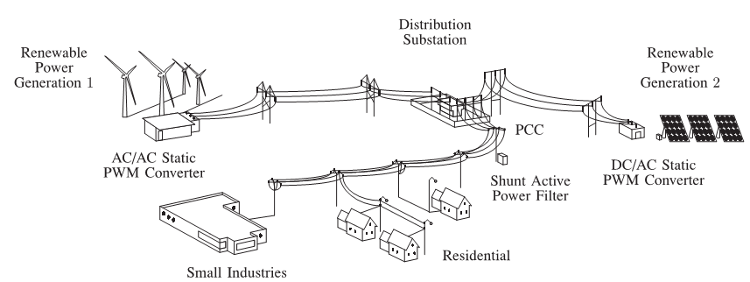

**Fig: 1** Stand-alone hybrid power generation system with a shunt active power filter.

However, the extensive use of power electronics based equipment and non-linear loads at PCC generate harmonic currents, which may deteriorate the quality of power [1], [2]. Generally, current controlled voltage source inverters are used to interface the intermittent RES in distributed system. Recently, a few control strategies for grid connected inverters incorporating PQ solution have been proposed. In [3] an inverter operates as active inductor at a certain frequency to absorb the harmonic current. But the exact calculation of network inductance in real-time is difficult and may deteriorate the control performance. A similar approach in which a shunt active filter acts as active conductance to damp out the harmonics in distribution network is proposed in [4]. In [5], a control strategy for renewable interfacing inverter based on – theory is proposed. In this strategy both load and inverter current sensing is required to compensate the load current harmonics.

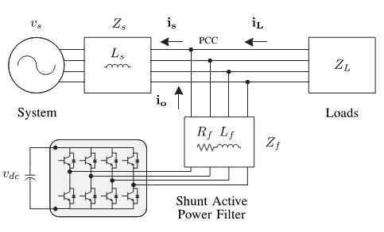

**Fig: 2** Three-phase equivalent circuit of the proposed shunt active power filter.

The non-linear load current harmonics may result in voltage harmonics and can create a serious PQ problem in the power system network. Active power filters (APF) are extensively used to compensate the load current harmonics and load unbalance at distribution level. This results in an additional hardware cost. However, in this paper authors have incorporated the features of APF in the, conventional inverter interfacing renewable with the grid, without any additional hardware cost. Here, the main idea is the maximum utilization of inverter rating which is most of the time underutilized due to intermittent nature of RES

This paper presents the mathematical model of the 4L-VSI and the principles of operation of the proposed predictive control scheme, including the design procedure. The complete description of the selected current reference generator implemented in the active power filter is also presented. Finally, the proposed active power filter and the effectiveness of the associated control scheme compensation are demonstrated through simulation and validated with experimental results obtained in a 2 kVA system.

1. **FOUR-LEG CONVERTER MODEL**

Fig. 1 shows the configuration of a typical power distribution system with renewable power generation. It consists of various types of power generation units and different types of loads. Renewable sources, such as wind and sunlight, are typically used to generate electricity for residential users and small industries. Both types of power generation use ac/ac and dc/ac static PWM converters for voltage conversion and battery banks for long term energy storage. These converters perform maximum power point tracking to extract the maximum energy possible from wind and sun. The electrical energy consumption behavior is random and unpredictable, and therefore, it may be single- or three-phase, balanced or unbalanced, and linear or nonlinear. An active power filter is connected in parallel at the point of common coupling to compensate current harmonics, current unbalance, and reactive power. It is composed by an electrolytic capacitor, a four-leg PWM converter, and a first-order output ripple filter, as shown in Fig. 2. This circuit considers the power system equivalent impedance Zs, the converter output ripple filter impedance Zf, and the load impedance ZL.

The four-leg PWM converter topology is shown in Fig. 3. This converter topology is similar to the conventional three-phase converter with the fourth leg connected to the neutral bus of the system. The fourth leg increases switching states from 8 (23 )to 16 (24 ), improving control flexibility and output voltage quality [21], and is suitable for current unbalanced compensation.

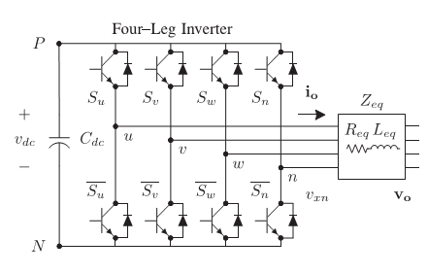

**Fig. 3.** Two-level four-leg PWM-VSI topology.

The voltage in any leg x of the converter, measured from the neutral point (n), can be expressed in terms of switching states, as follows:



The mathematical model of the filter derived from the equivalent circuit shown in Fig. 2 is



Where Req and Leq are the 4L-VSI output parameters expressed as Thevenin impedances at the converter output terminals Zeq.

1. **DIGITALPREDICTIVE CURRENT CONTROL**

The block diagram of the proposed digital predictive current control scheme is shown in Fig. 4. This control scheme is basically an optimization algorithm and, therefore, it has to be implemented in a microprocessor. Consequently, the analysis has to be developed using discrete mathematics in order to consider additional restrictions such as time delays and approximations

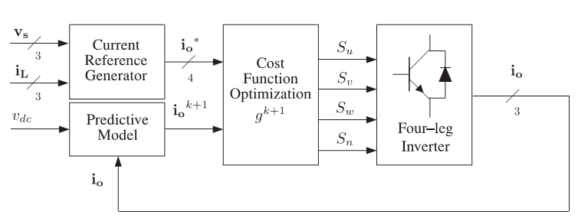

**Fig. 4.** Proposed predictive digital current control block diagram

The main characteristic of predictive control is the use of the system model to predict the future behavior of the variables to be controlled. The controller uses this information to select the optimum switching state that will be applied to the power converter, according to predefined optimization criteria. The predictive control algorithm is easy to implement and to understand, and it can be implemented with three main blocks, as shown in Fig. 4.

1. **CURRENT REFERENCE GENERATION**

A dq-based current reference generator scheme is used to obtain the active power filter current reference signals. This scheme presents a fast and accurate signal tracking capability. This characteristic avoids voltage fluctuations that deteriorate the current reference signal affecting compensation performance [28]. The current reference signals are obtained from the corresponding load currents as shown in Fig. 5. This module calculates the reference signal currents required by the converter to compensate reactive power, current harmonic and current imbalance. The displacement power factor (sinφ(L)) and the maximum total harmonic distortion of the load (THD(L)) defines the relationships between the apparent power required by the active power filter, with respect to the load, as shown

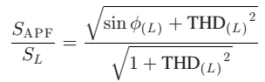

Where the value of THD (L) includes the maximum compensable harmonic current, defined as double the sampling frequency fs. The frequency of the maximum current harmonic component that can be compensated is equal to one half of the converter switching frequency. The dq-based scheme operates in a rotating reference frame; therefore, the measured currents must be multiplied by the sin(wt)and cos(wt)signals. By using dq-transformation, the d current component is synchronized with the corresponding phase-to-neutral system voltage, and the q current component is phase-shifted by 90 ◦ .The sin(wt)and cos(wt)synchronized reference signals are obtained from a synchronous reference frame (SRF) PLL. The SRF-PLL generates a pure sinusoidal waveform even when the system voltage is severely distorted.

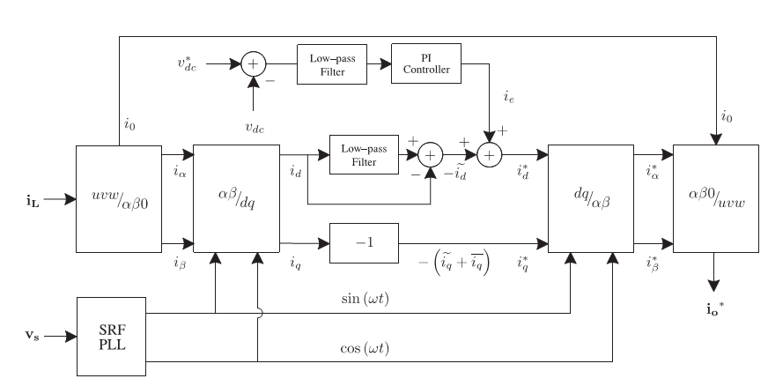

**Fig. 5.** dq-based current reference generator block diagram.

Tracking errors are eliminated, since SRF-PLLs are designed to avoid phase voltage unbalancing, harmonics (i.e., less than 5% and 3% in fifth and seventh, respectively), and offset caused by the nonlinear load conditions and measurement errors [30]. Equation (8) shows the relationship between the real currents iLx(t)(x=u, v, w) and the associated dq components (id and iq)

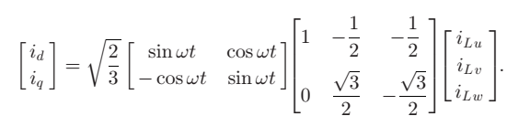

The current that flows through the neutral of the load is compensated by injecting the same instantaneous value obtained from the phase-currents, phase-shifted by 180◦, as shown next



One of the major advantages of the dq-based current reference generator scheme is that it allows the implementation of a linear controller in the dc-voltage control loop. However, one important disadvantage of the dq-based current reference frame algorithm used to generate the current reference is that a second order harmonic component is generated in id and iq under unbalanced operating conditions. The amplitude of this harmonic depends on the percent of unbalanced load current (expressed as the relationship between the negative sequence currentiL,2 and the positive sequence currentiL,1). The second-order harmonic cannot be removed from id and iq, and therefore generates a third harmonic in the reference current when it is converted back to abc frame. Fig. 6 shows the percent of system current imbalance and the percent of third harmonic system current, in function of the percent of load current imbalance. Since the load current does not have a third harmonic, the one generated by the active power filter flows to the power system.

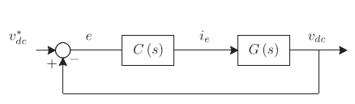

**Fig. 6.** DC-voltage control block diagram.

A. DC-Voltage Control

The dc-voltage converter is controlled with a traditional PI controller. This is an important issue in the evaluation, since the cost function (6) is designed using only current references, in order to avoid the use of weighting factors. Generally, these weighting factors are obtained experimentally, and they are not well defined when different operating conditions are required. Additionally, the slow dynamic response of the voltage across the electrolytic capacitor does not affect the current transient response. For this reason, the PI controller represents a simple and effective alternative for the dc-voltage control. The dc-voltage remains constant (with a minimum value of √ 6vs (rms)) until the active power absorbed by the converter decreases to a level where it is unable to compensate for its losses.

1. **PHOTOVOLTAIC SYSTEM**

A Photovoltaic (PV) system directly converts solar energy into electrical energy. The basic device of a PV system is the PV cell. Cells may be grouped to form arrays. The voltage and current available at the terminals of a PV device may directly feed small loads such as lighting systems and DC motors or connect to a grid by using proper energy conversion devices.

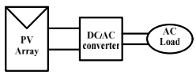

Fig.7. Block diagram representation of Photovoltaic system

This photovoltaic system consists of three main parts which are PV module, balance of system and load. The major balance of system components in this systems are charger, battery and inverter. The Block diagram of the PV system is shown in Fig.7.

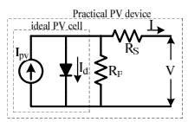

**Fig.8**. Practical PV device

A photovoltaic cell is basically a semiconductor diode whose p–n junction is exposed to light. Photovoltaic cells are made of several types of semiconductors using different manufacturing processes. The incidence of light on the cell generates charge carriers that originate an electric current if the cell is short circuited1

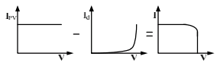

**Fig.9.** Characteristics I-V curve of the PV cell

The equivalent circuit of PV cell is shown in the fig.8. In the above figure the PV cell is represented by a current source in parallel with diode. Rs and Rp represent series and parallel resistance respectively. The output current and voltage form PV cell are represented by I and V. The I-V characteristics of PV cell are shown in fig.9. The net cell current I is composed of the light generated current IPV and the diode current ID.

1. **SIMULATION RESULTS**

*Case 1: Predictive control Scheme for 4-Leg APF*

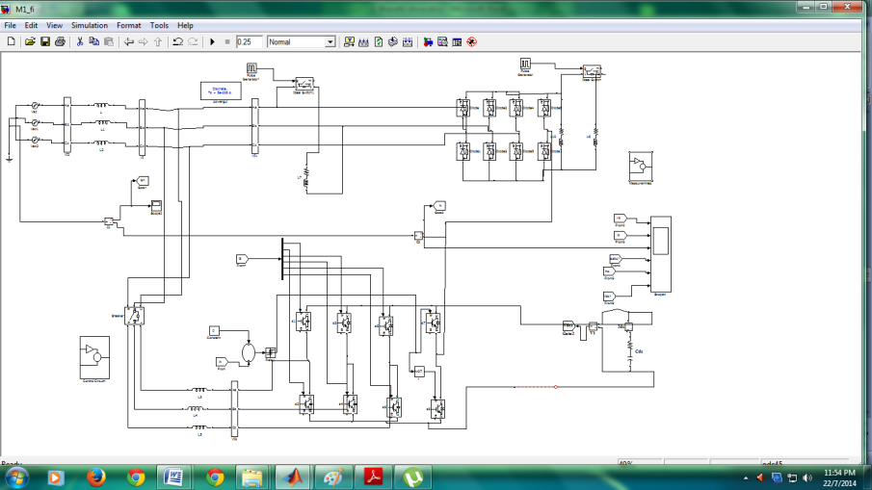

**Fig.10** Shows the MATLAB/SIMULINK model of Predictive control Scheme for 4-Leg APF

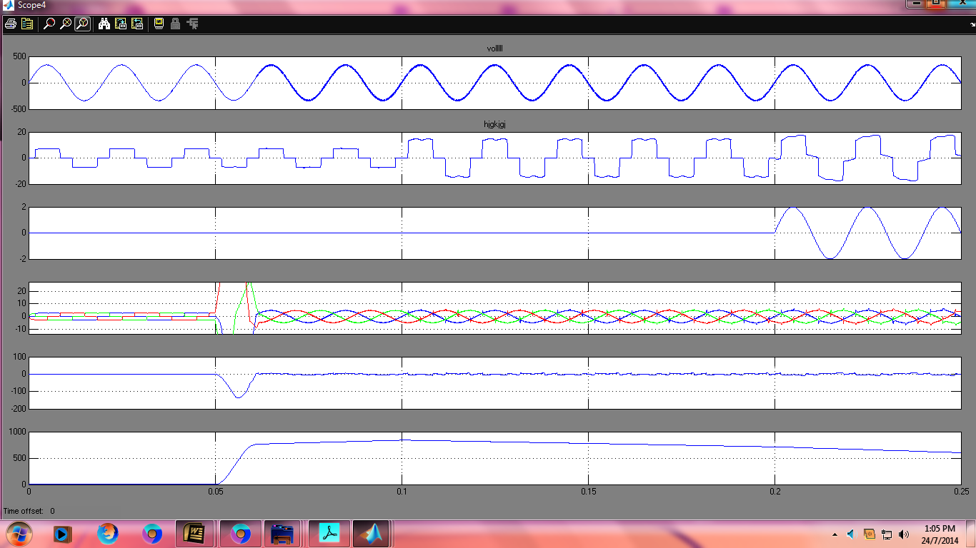

**Fig. 11** Simulated waveforms of the proposed control scheme (a) Phase to neutral source voltage (b) Load Current (c) Load neutral current. (d) Three phase source current. (e) compensating currents. (f) DC voltage converter.

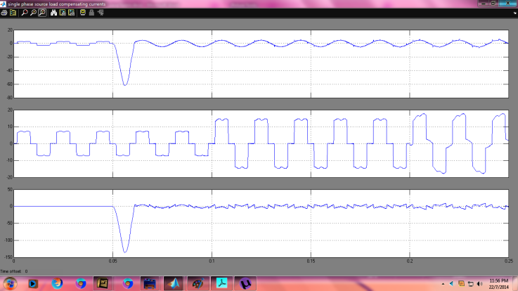

**Fig.12** Simulated waveforms of single phase source load compensating currents

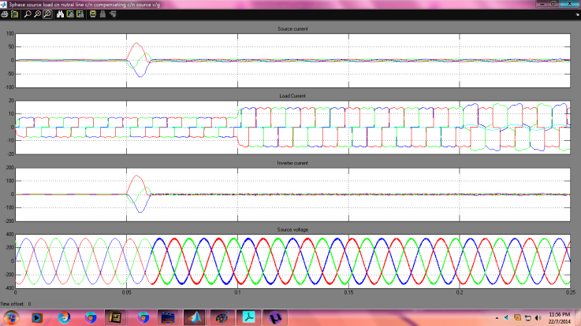

**Fig.13** Simulated waveforms of 3-phase source load current neutral line current compensating current source voltage

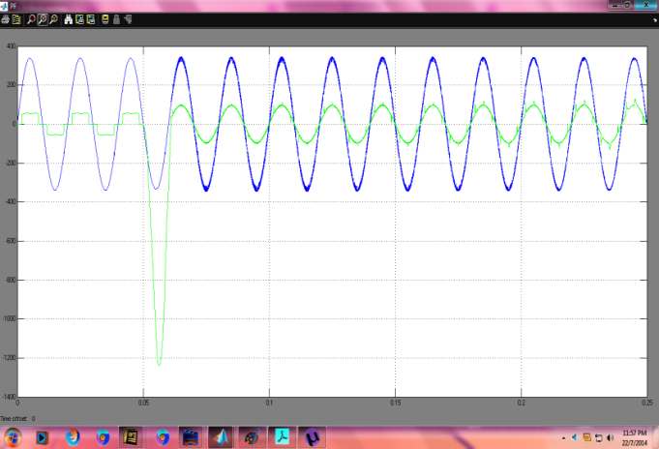

**Fig.14** shows the Power factor

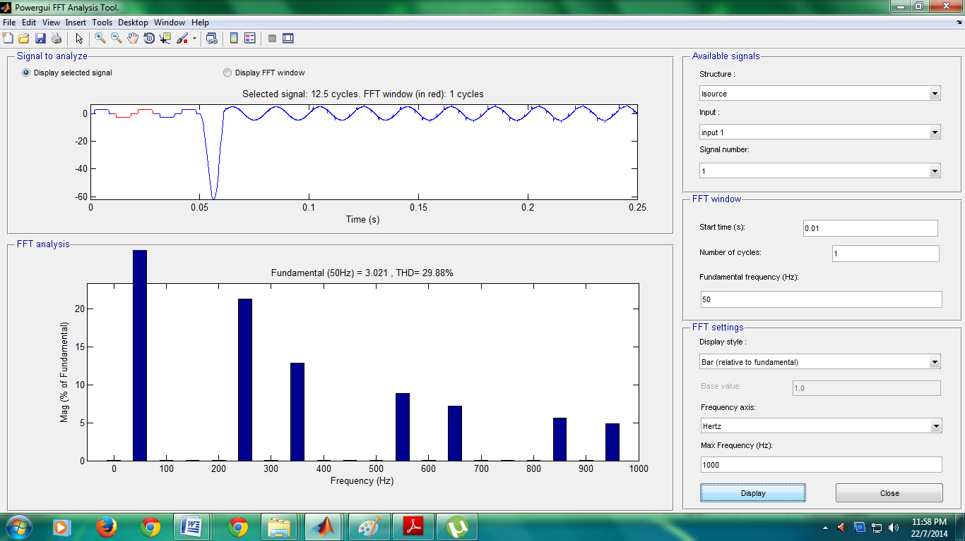

**Fig.15** shows the total harmonic distortions 29.988%

*Case 2: Predictive control Scheme for PV based 4-Leg APF*

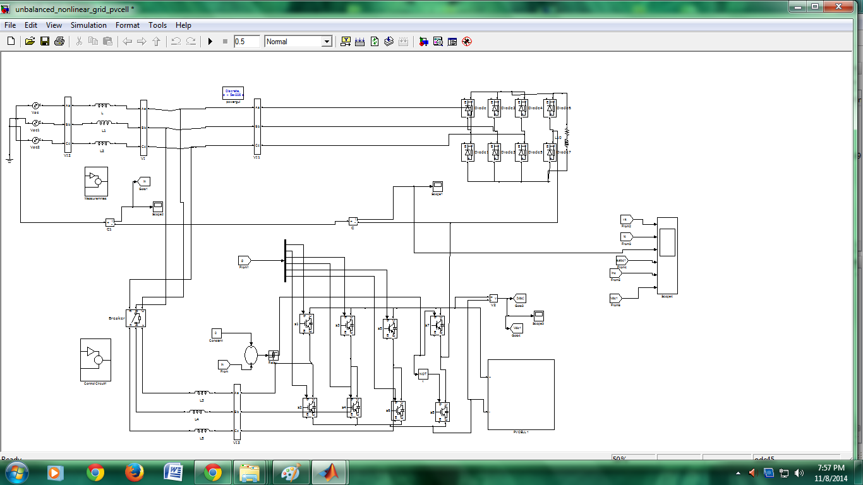

**Fig.16** Shows the MATLAB/SIMULINK model of Predictive control Scheme for PV based 4-Leg APF

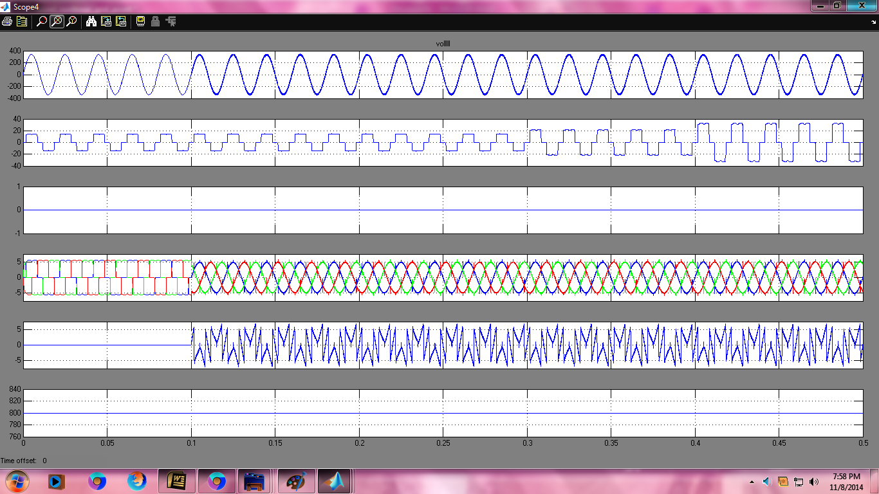

**Fig. 17** Simulated waveforms of the proposed control scheme with PV as source (a) Phase to neutral source voltage (b) Load Current (c) Load neutral current. (d) Three phase source current (e) compensating currents. (f) DC voltage converter.

1. **CONCLUSION**

This concept Simulation of 4-Leg Inverter based APF for PV based System with Effective Controller is used to improve the power quality. The use of a predictive control for the converter current loop proved to be an effective solution for active power filter applications.This paper presented a control of Three phase Four leg grid interfacing inverter improve the quality of power at PCC for a 3 phase 4 wire system. Thus the proposed controller precisely manages any variation in real power at dc link and effectively feeds it to the main grid. 4-Leg Inverter based APF for PV based System in this RES used as a source.

**REFERENCES**

1. P. Cortes, G. Ortiz, J. Yuz, J. Rodriguez, S. Vazquez, and L. Franquelo,“Model predictive control of an inverter with outputLCfilter for UPS applications,”IEEE Trans. Ind. Electron., vol. 56, no. 6, pp. 1875–1883,Jun. 2009.
2. R. Vargas, P. Cortes, U. Ammann, J. Rodriguez, and J. Pontt, “Predictive control of a three-phase neutral-point-clamped inverter,”IEEE Trans. Ind.Electron., vol. 54, no. 5, pp. 2697–2705, Oct. 2007.
3. P. Cortes, A. Wilson, S. Kouro, J. Rodriguez, and H. Abu-Rub, “Model predictive control of multilevel cascaded H-bridge inverters,”IEEE Trans. Ind. Electron., vol. 57, no. 8, pp. 2691–2699, Aug. 2010.
4. P. Lezana, R. Aguilera, and D. Quevedo, “Model predictive control of an asymmetric flying capacitor converter,”IEEE Trans. Ind. Electron., vol. 56, no. 6, pp. 1839–1846, Jun. 2009.
5. P. Correa, J. Rodriguez, I. Lizama, and D. Andler, “A predictive control scheme for current-source rectifiers,”IEEE Trans. Ind. Electron., vol. 56, no. 5, pp. 1813–1815, May 2009.
6. M. Rivera, J. Rodriguez, B. Wu, J. Espinoza, and C. Rojas, “Current control for an indirect matrix converter with filter resonance mitigation,”
7. IEEE Trans. Ind. Electron., vol. 59, no. 1, pp. 71 79, Jan. 2012.
8. P. Correa, M. Pacas, and J. Rodriguez, “Predictive torque control for inverter-fed induction machines,” IEEE Trans. Ind. Electron., vol. 54, no. 2, pp. 1073–1079, Apr. 2007.
9. M. Odavic, V. Biagini, P. Zanchetta, M. Sumner, and M. Degano, “Onesample-period ahead predictive current control for high performance active shunt power filters,”Power Electronics, IET, vol. 4, no. 4, pp. 414–423, Apr. 2011.
10. D. Quevedo, R. Aguilera, M. Perez, P. Cortes, and R. Lizana, “Model predictive control of an AFE rectifier with dynamic references,”IEEE Trans. Power Electron., vol. 27, no. 7, pp. 3128–3136, Jul. 2012.
11. Z. Shen, X. Chang, W. Wang, X. Tan, N. Yan, and H. Min, “Predictive digital current control of single-inductor multiple-output converters in CCM with low cross regulation,”IEEE Trans. Power Electron., vol. 27, no. 4, pp. 1917–1925, Apr. 2012.