A New Multilevel Inverter Based Wind Generation System with Power Factor Correction

Dr.K Mekala*,M Rakesh**

Department of EEE,SreeDattha Institute of Engineering & Science

***Abstract:* The implementation of power converters and power factor correction by using five level multi level inverts for wind generator is proposed in this project. In this project we are using a wind generator, a three phase ac/dc full-bridge semi controlled boost rectifier, a dc/dc single-ended primary inductance converter (SEPIC), a bi-directional converter and multilevel inverter. Mainly in this system the wind generator is used as the main power source and lead-acid batteries as the auxiliary power source. In this project main thesis is to power factor correction by reducing the harmonics to achieve unit power factor and maximum power point tracking (MPPT), thus to improve the overall system performance and reduces the harmonics in a large amount to achieve pure sine wave . In existing system normal full ridge inverter is used but it needs very large LC filters. It produces large harmonics to obtain pure sine wave. So in the proposed system we are using the five level multilevel inverter. In addition, the bidirectional converter provides charging and discharging compensation to dc bus by controlling the duty cycle of switches. Finally, the multilevel inverter produces a stable ac output with feedback.**

***Keywords—wind generator; bi-directional dc/dc converter; the***

***Maximum power point tracking; five level multi level inverter; three-phase power factor correction.***

**I.INTRODUCTION**

In recent years, wind energy technology has become one of the top areas of interest for energy harvesting in the power electronics world. This interest has especially peaked recently due to the increasing demand for a reliable source of renewable energy. There has been very little research in low power AC/DC converters for low to medium power wind energy turbines for battery charging applications. Due to the low power coefficient of wind turbines, power converters are required to transfer the maximum available power at the highest efficiency Power factor correction (PFC) and maximum power point tracking (MPPT) algorithms have been proposed for high power wind turbines[1]. They also occupy a large amount of space, which is not practical for use in one's home. A wind generator consists of blades and a turbine. Fig. 1 shows the blades of wind generator, and blades are divided into two categories: one is the horizontal axis turbine, which is used generally such as propeller type, multi-blade type, Dutch type and windsurfing type, etc [2]. It can be applied to the place which has fixed wind for obtaining higher output. A low cost AC/DC converter with ancient power transfer is needed in order to promote the use of cheaper low power wind turbines. A wind turbine can be defined as a machine that takes kinetic energy from the wind and converts it to mechanical energy. This machine transfers the motion to an electric generator shaft. Almost every low to medium power wind turbine is designed to supply a three phase AC where the frequency varies with the speed of the wind. However, these turbines operate with very low power coefficient. Therefore, an efficient three phase AC/DC converter with MPPT algorithm is very much needed for these types of applications when charging a DC battery supply This project will start by introducing the design of power converters that can be realized for the power conversion of low to medium power wind turbines and use it to efficiently charge a 12V or 24V battery. This project will also introduce a unique way for obtaining maximum power out of a low power wind turbine. It will also explain various control loops that were added to the system in order to better protect both the converter and the wind turbine [3]. The introduction of power factor correction in low to medium power 3 phase wind turbine is discussed in this thesis. It is important to not only focus on the electrical efficiency, but the mechanical efficiency of the source as well. The wind turbine can behave more efficiently by making an electrical converter appear like a resistive load to the source.

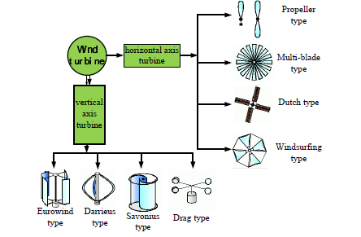

Figure 1. Types of wind turbines.

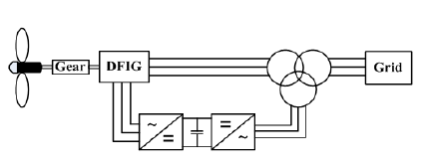

Figure 2. The wind power conversion system of DFIG.

.

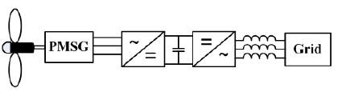

Figure 3. The wind power conversion system of PMSG

The wind power conversion system on the constant speed is implemented for the grid connected, which requires a larger blade is needed. Fig. 2 shows that the DFIG(doubly fed induction generator) shows the frequency and voltage by magnetizing current, and this category is applied to the variable wind speed of the wind power conversion system for grid-connected. The system in Fig.2 allows high power transmitted to the power electronic devices, because the power converter only handles about nominal power 30%. On the other hand, the system requires a gearbox between the wind turbine and the generator in order to reduce the number of poles of DFIG, so that can not only increases volume and cost but also decrease the efficiency and reliability. But these problems do not exist in PMSG, as shown in Fig. 3. However, the PMSG requires a power converter to adjust the magnitude of output before the grid connected; hence the output power is limited.

II. TOPOLOGIES OF THE PROPOSED SYSTEM

The proposed wind power generation converter system mainly uses PMSG (permanent magnet synchronous generator) to provide electricity to the load and employs a lead-acid bi directional battery to avoid the wind power provide electricity to the load intermittently. The lead-acid can not only absorb extra energy but also provide energy to the load that means it works as a bi directional converter. Fig. 4 shows the topologies of the proposed system that consists of three phase ac/dc full-bridge semi controlled rectifier, SEPIC

(DC-DC) variable dc to fixed dc converter, bi-directional dc/dc converter and five level multi level inverter. The proposed system improves the harmonic distortion and reduces the LC filter size and the power factor that makes the wind generator to reduce the noise and the balances three phase. The system with power electronic technology achieves higher efficiency and stability and unity power factor. Each converter operating is introduced as following. To improve the output of current harmonics and power factor of the wind generator, the rectifier is employed. The semi controlled rectifier is similar to a boost converter [1] [2]. The currents corresponding to the inductors (L1, L2, L3) are increase when the switches (S1, S2, S3) are turned on, and the corresponding diodes (D1, D2, D3) conduct when the switches (S1, S2, S3) are turned off. The power flow is transferred from wind generator to the rectifier. The dc bus can be compensated fast by the bi-directional converter. According to the different conditions of dc bus, it can play in the charged or discharged role. In other words, the power flow is variable, and needs to decide the input and output on the basis of the circuit current. The converter is applied to a hybrid power system, a fuel cell, an uninterruptible power system or a renewable energy conversion system [3]. These system topologies can not only be compensated but also store energy by the bi-directional converter connected with batteries. The proposed system is employed with the five level multi level inverter; due to its output voltage is twice of the half-bridge inverter under the same input voltage.

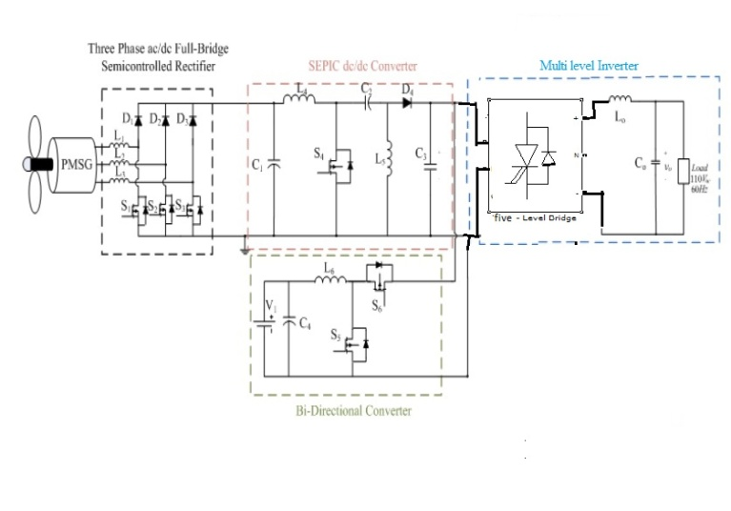

Figure 4. Topologies of the proposed system.

III. CONTROL STRATEGY

To increase the stability and the output efficiency, the semi controlled rectifier is used in this project in the input side. The proposed control method implements the quasi-synchronous rectification (QSR) with PWM to make the voltage and current in the same phase. Fig.5 shows topologies of the semi controlled rectifier The duty cycles of each of switches are shown in the following, where the voltage reference Veq and duty cycle are assumed to 90V and 0.3, respectively. DS1, DS2 and DS3 are the duty cycles of S1, S2 and S3, respectively, and the switching frequency is 25 kHz. The duty cycles of switches and operating status of the converter are modulated by the following formulas (1), (2) and (3).

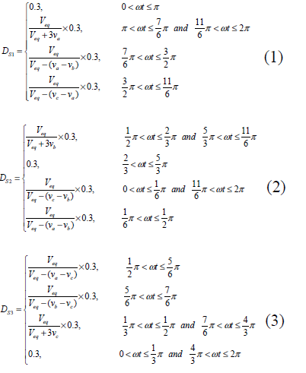

The duty cycle of SEPIC (single ended primary inductance converter) converter is implemented with the MPPT to achieve maximum power, which provides the bidirectional converter to charge the battery and the five level multi level

inverter as the source. The system obtains the output voltage VDC_bus and the output current IDC_bus from SEPIC converter as a basis for perturbation and observation (P&O) method. DC bus can be compensated by the bi-directional converter. The schematic diagram of hysteresis of dc bus is shown in Fig.6. The charging or discharging mode of the bi directional converter depends on the hysteresis of dc bus [4]. The strategy can storage the additional energy to battery, and supply the energy for power supply. The control flow of system uses the sinusoidal PWM by a single-phase half-bridge inverter to convert dc-link voltage (190-210V) into ac voltage (110Vrms, 60Hz). The control method is implemented a sinusoidal reference signal with built in DSP to product a sine-wave signal and to compare with a triangular waveform. Due to the switching frequency (fs) and the output frequency (fo) are 18 kHz and 60Hz, the low frequency switch dB and dA under the positive half cycle are on and off, respectively. In the other hand, dB and dA under the negative half cycle are off and on, respectively. AC output voltage is implemented with a filter circuit consisted of Lo and Co, and the feedback of ac voltage *vo* is compared with the sinusoidal signal of built in sine wave (Vo_ref). Moreover, the output current of the inductance and the feedback current that controlled by voltage and current circuits will obtain the switching signal of SA+ and SA-.

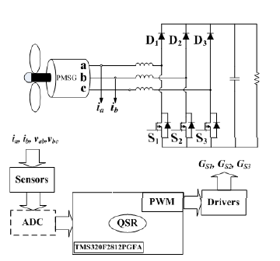

Figure 5. The schematic diagram of digital controller of semi controlled

Rectifier



Figure 6. The schematic diagram of hysteresis of dc bus.

IV. MATLAB MODELING BLOCK DIAGRAM SIMULATION RESULTS

From the wind generation by using full bridge inverter it require large LC filter and it will not give pure sine wave and it has large amount of harmonic present so in order to reduce this draw back we are using a five level neutral point clamped multi level inverter .A new multilevel inverter based wind generation system with power factor correction simulink model as shown fig.7. The fig.8. Shows the simulink model of control signal applied to the phase rectifier to convert the BLDC motor output i.e AC into DC. Figure 9.Shows the instantaneous voltage of variable load under high voltage condition here we placing the breaker. Instantaneous current of variable load under high voltage condition shown in fig. 10. Fig.11.Shows the harmonics of full bridge inverter output voltage. The input waveform of passive rectifier in a phase (without PFC) shown in fig.12

Fig.13. Shows the harmonics of the five level multi level inverter output voltage here we reduced the THD value from 99.5% to 18.79%. Fig.14. Shows the Output voltage of five level multi level inverter in single phase manner Fig. 15.Shows the PWM signal of the five level multi level inverter here reference signal is sinusoidal and carrier signal is triangle wave

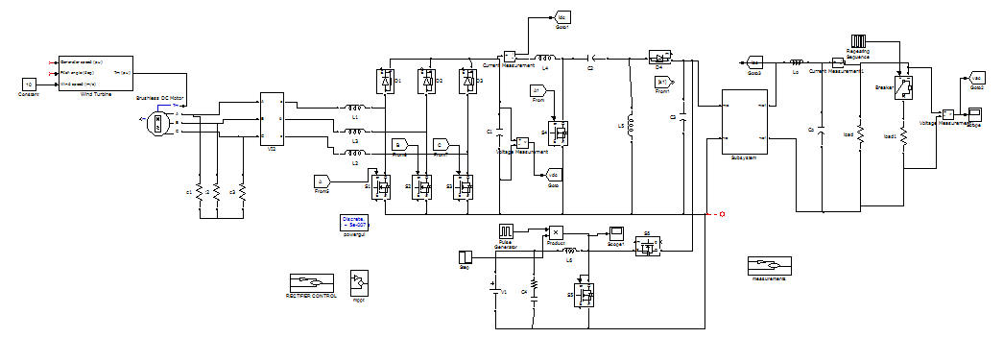

Fig. 7. Shows the block diagram of the multi level inverter wind generation system with power correction

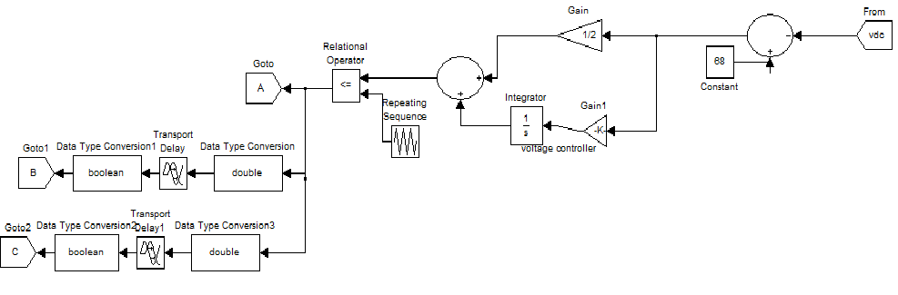

Fig.8. Shows the simulink model of control signal applied to the phase rectifier

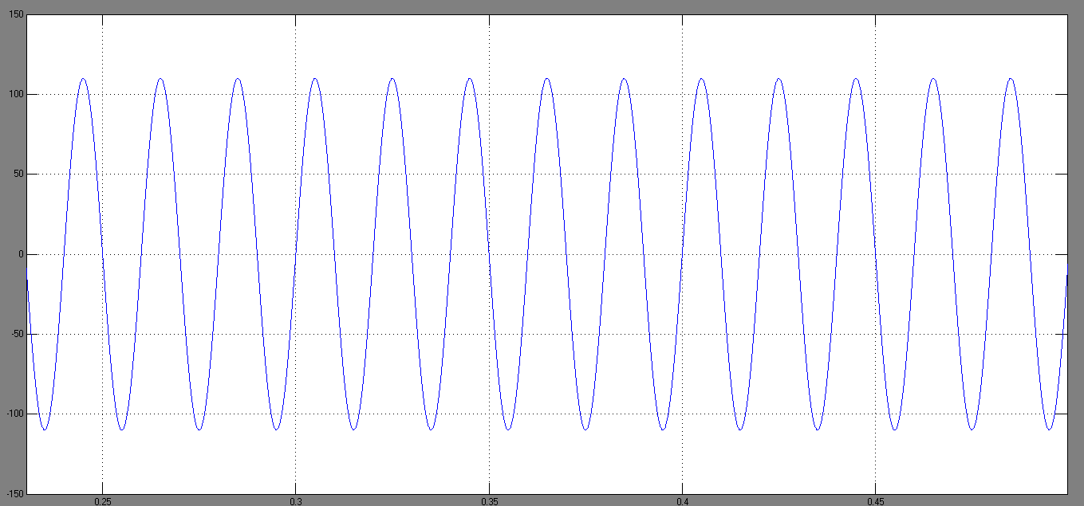

Figure 9. The instantaneous voltage of variable load under high voltage

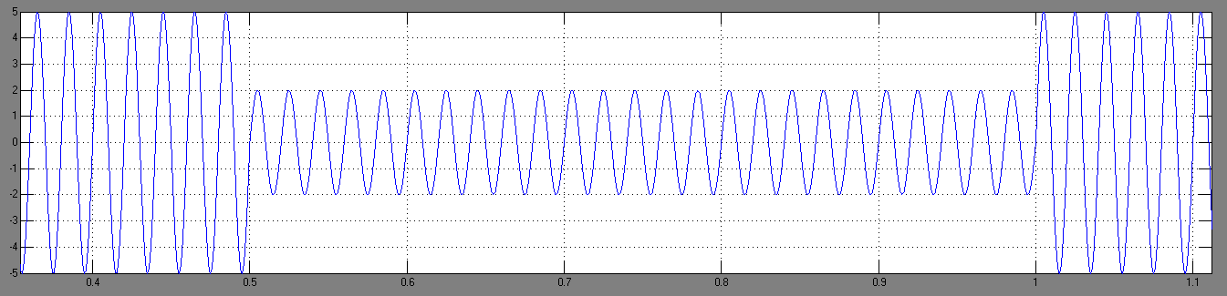

Figure 10. The instantaneous current of variable load under high voltage

In the wind generation system by using several power converters like semi controlled rectifier, SEPIC (dc-dc) converter, and lead acid battery, full bridge inverter we are not getting the pure sine wave and harmonics also present in a large amount i.e 99.55% as shown in the figure 11. With the fundamental frequency of 50hz.

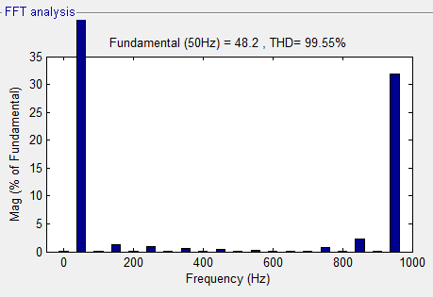

Fig .11.Shows the harmonics of full bridge inverter output voltage

As shown in the figure.12 the out put voltage and current are in out of phase to each other so the power factor also will not be unity then the system performance also reduces and efficiency is less for that purpose we are using a five level neutral point clamped multilevel inverter is used in this project.Then see the out puts of the system while using the multi level inverter in figure.13. the harmonics are reduced from 99.5% to 18.79%. then the out put wave form of the multi level inverter is shown in the figure.14 it shows fivel level inverter i.e very near to sine wave . and in the figure.15 the out put sine wave is compared with the pwm signal with five level multi level inverter.

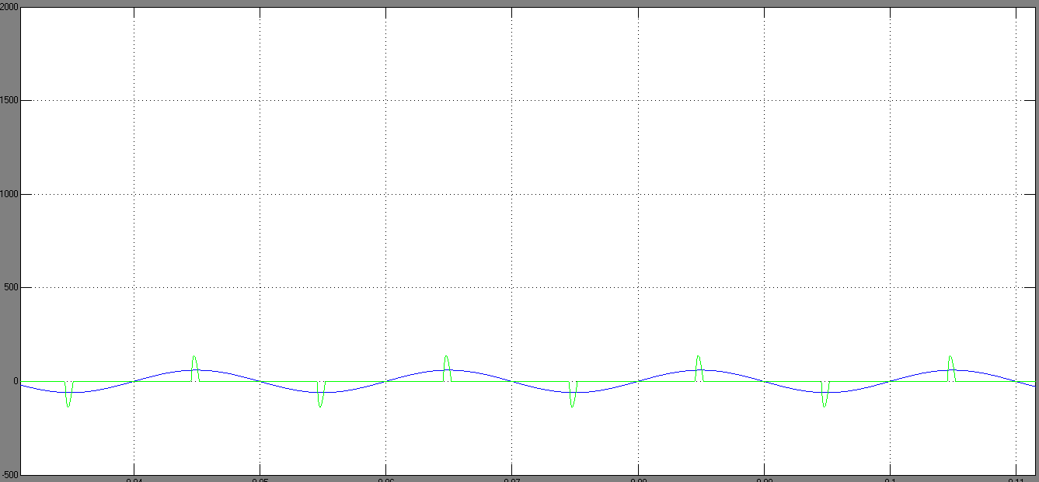

Fig.12. The input waveform of passive rectifier in a phase (without PFC)

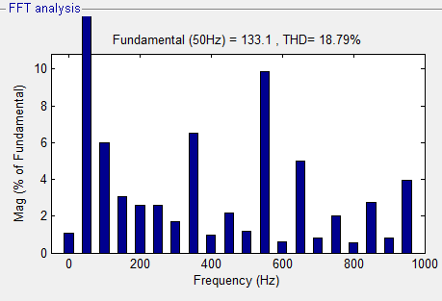

Fig.13. Shows the harmonics of the five level multi level inverter output voltage

.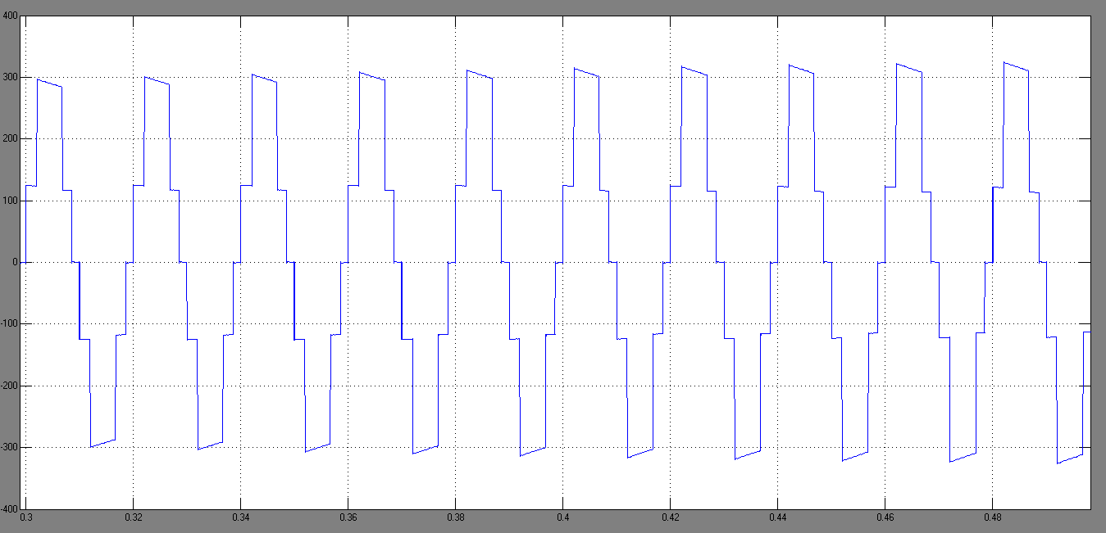

figure.14 Shows fivel level inverter output voltage

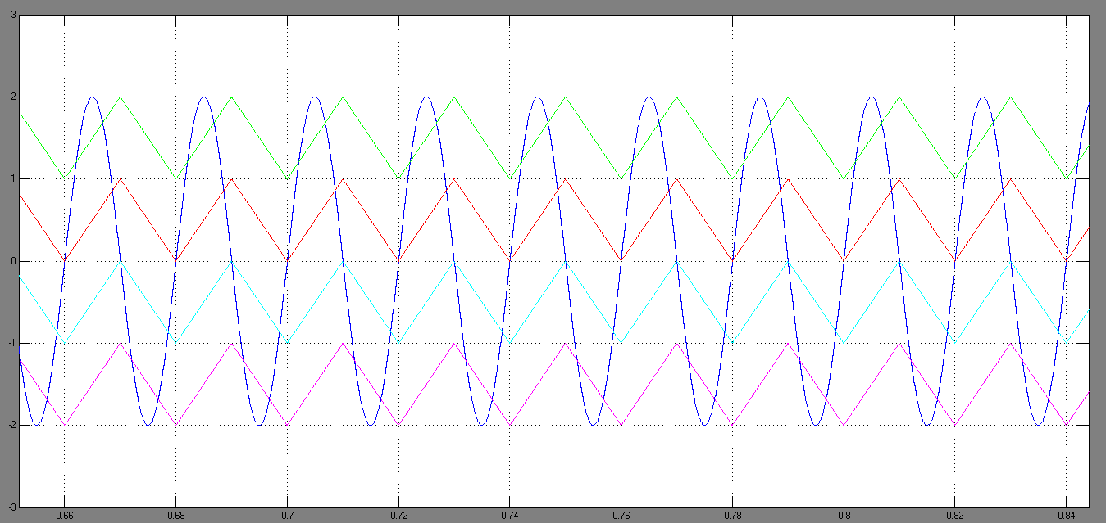

Fig. 15.Shows the PWM signal of the five level multi level inverter

V.CONCLUSION

By properly designing the converter components, the relation between efficiency and harmonic content can be established to obtain the pure sin wave and efficiency as high as possible. The generation of power conversion system for wind generator is presented in this project. In the control strategy of five level multi level inverter, the system achieves high stability, low harmonic content and available maximum power point by using quasi-synchronous rectification and P&O method by using neutral point clamped five level multi level inverter. With the proper control of the wind generator and power converters, the output power will be balanced effectively. A dc bus hysteresis detection mechanism is designed to control the battery; therefore, the power flow between the battery and the dc bus can be controlled by acting as a bi-directional converter for charging and discharging. Then at the last, the feedback controller can compensate the output of the inverter accurately when input voltage or output load changes. Then the harmonics are reduced and size of the LC filter also reduced. No matter what the atmospheric conditions are, the proposed system makes the load-side maintain a stable ac output voltage.

REFERENCES

[1] Cattle spring, “The Illustrated Wind Power Getting Started,” Hsiao Publishing Limited, November 2013.

[2] D. S. Oliveira, Jr., M. M. Reis, C. E. A. Silva, L. H. S. C Barrett, F. L. M. Attunes, and B. L. Soars, “A Three-Phase High-Frequency Semi controlled Rectifier for PM WECS,” IEEE Trans. Power Electron., vol. 25, no. 3, pp.677–685, Mar. 2013.

[3] S. Arabic, N. Celanovic, and V.A. Katic, “Permanent magnet synchronous generator cascade for wind turbineapplication,” IEEE Trans. Power Electron., vol. 23, no. 3, pp. 1136–1142, May 2010.

[4] J. M. Carrasco, L. G. Franquelo, J. T. Bialasiewicz, E. Galvan, R. C. P. Guisado, M. A. M. Prats, J. I. Leon, and N. Moreno-Alfonso, “Powerelectronic systems for the grid integration of renewable energy sources: A survey,” IEEETrans. Ind. Electron., vol. 53, no. 4, pp. 1002–1016, Jun. 2013.

[5] F. Blaabjerg, R. Teodorescu, M. Liserre, and A. V. Timbus, “Overview of control and grid synchronization for distributed power generation systems,” IEEE Trans. Ind. Electron., vol. 53, no. 5, pp. 1398–1409, Oct. 2010.

[6] C. T. Pan, and Y. L. Juan,”A Novel Sensorless MPPT Controller for a High-Efficiency Microscale Wind Power Generation System,” IEEE Trans. on Energy Convers., vol. 25, no. 1, pp. 207–216,March 2010.

[7] R. Thresher, M. Robinson, and P. Veers, “To Capture the Wind,” IEEE power & energy magazine,November/December 2009