**Embedded Technology for vehicle cabin safety Monitoring and Alerting System**

**Dr sandeipan p narote1, P Bramheswar rao2, L Ramesh3**

**1,2,3Department of ECE, Sree Dattha Institute of Engineering & science**

**Abstract**: Motor vehicles are the prime source of transportation where vehicles with A/C play a major part. This paper designs an embedded system for a vehicle cabin, which senses the gases like carbon-monoxide and oxygen and displayed at each and every second. If the level of the CO increases than the normal level (30ppm) or the level of the oxygen decreases than the normal level (19%) then an alarm is generated automatically and also ventilation is provided immediately. A warning message is sent to the authorized user via GSM. The advantage of this system is proper detection and faster response time leading to faster diffusion of the situation, compared with the manual methods.

**Keywords**

Atmel microcontroller; Embedded System; Gas detecting sensors; GSM Modem; Vehicle Safety;

**1. INTRODUCTION**

Motor vehicles are they not only the prime source of transportation, but also the prime source of pollution. These motor vehicles contribute to over 30% of the hazardous gases that are released into the atmosphere. Outdoor pollution levels are the key concern, but the quality of air inside the vehicle plays a major part. As the vehicle cabin is small area, any suspended particulate such as dust, fumes, smokes entering in to it through either ventilation or through windows can cause serious health problems to the person inside. These particulate matters can cause problems which may differ from acute and chronic effects on human health. The health effects range from minor irritation of eyes and the upper respiratory system to chronic respiratory disease, heart disease, lung cancer and even death.

Even if the vehicle is equipped with the air cabin filters that are present inside the cabin so as to reduce the effect of the unwanted particulate, they cannot be a viable solution to control it. Even though the producers of various vehicles mainly concentrate on these safety precautions, the carelessness of the end users or the drivers regarding the condition of the vehicle may cause serious damage not only to the vehicles but also to the human lives. Such that even the minor eye irritation can make the driver to lose his concentration on the road, which may lead to serious accidents. Hence to overcome these types of problems there is a need to monitor several gases

Such as carbon monoxide (CO) and the oxygen level is required to ensure complete vehicle occupant comfort and safety. The embedded system is used inside a vehicle cabin such that the presence or leakage of toxic gases can be detected by the gas sensors and proper precautions can be taken to avoid the driver from getting fatigue or drowsiness [8].

Headache, dizziness, weakness, nausea, vomiting, chest pain, and confusion are the most common symptoms of CO poisoning. This paper designs an embedded system for toxic gas CO and oxygen level detection inside the vehicle cabin and to develop a sensing system using a sensor array and microcontroller. If the toxic gas reaches the maximum threshold level, the detection unit detects, an alarm is generated immediately and the ventilation will be provided automatically. And then an SMS is send to the authorized user through the GSM module [7].

**2.** **HARDWARE DESCRIPTION**

**2.1. Atmel 89c51 Microcontroller**

The AT89C51 is a low-power, high-performance CMOS 8-bit microcomputer with 4K bytes of Flash programmable and erasable read only memory (PEROM). The device is manufactured using Atmel’s high-density nonvolatile memory technology and is compatible with the industry-standard MCS-51 instruction set and pin out. The on-chip Flash allows the program memory to be reprogrammed in-system or by a conventional Nonvolatile memory programmer. By combining a versatile 8-bit CPU with Flash on a monolithic chip, the Atmel AT89C51 is a powerful microcomputer which provides a highly-flexible and cost-effective solution to many embedded control applications. Figure1 shows the model of Atmel 89c51. In addition, the AT89C51 is designed with static logic for operation down to zero frequency and supports two software selectable power saving modes. The Idle Mode stops the CPU while allowing the RAM, timer/counters, serial port and interrupt system to continue their functioning. The Power-down Mode saves the RAM contents but freezes the oscillator, disabling all other chip functions until the next hardware reset..

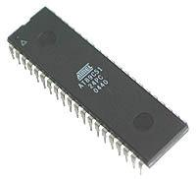

Figure 1. Atmel 89c51

**2.2. Block Diagram**

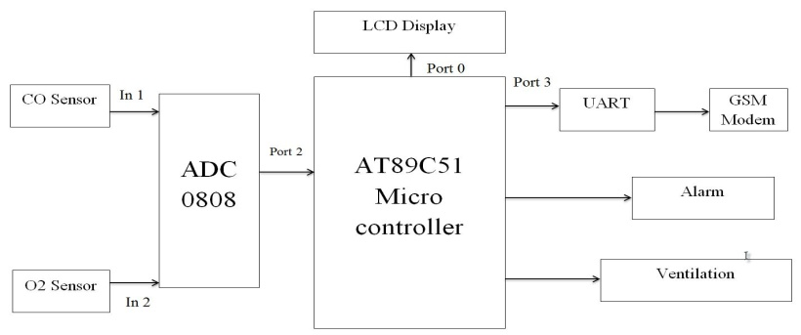

Figure 2. Block Diagram of the System

The AT89C51 micro controller is connected to the Analog to digital converter such that the input from the sensors are converted into digital input and then sent to the microcontroller it then displays the result through LCD. If a critical situation is experienced then an alarm is given for alerting the diver and ventilation is provided as an exhaust and as a remedy measure. A text message is sent to the authorized user indicating the critical situation of the vehicle. The block diagram of the proposed system is shown in figure2.

**3.** **Implementation**

The level of the toxic gas CO is continuously sensed by the sensor MQ-7. The level is displayed in the LCD continuously for each and every second. When the level of the toxic gas CO exceeds the normal level of 30ppm or the level of Oxygen decreases the normal level of 19.5%, then the microcontroller proceeds with an alarm. The GSM modem inside the vehicle sends a message to the authorized user about the alarming situation inside the cabin with the levels of the gases monitored by the sensors. Then ventilation is provided, so that the level of the toxic gases can be lowered as early as possible. This provides an immediate response to the situation which is an added advantage of the system. The prototype of the proposed system is shown in Figure8.

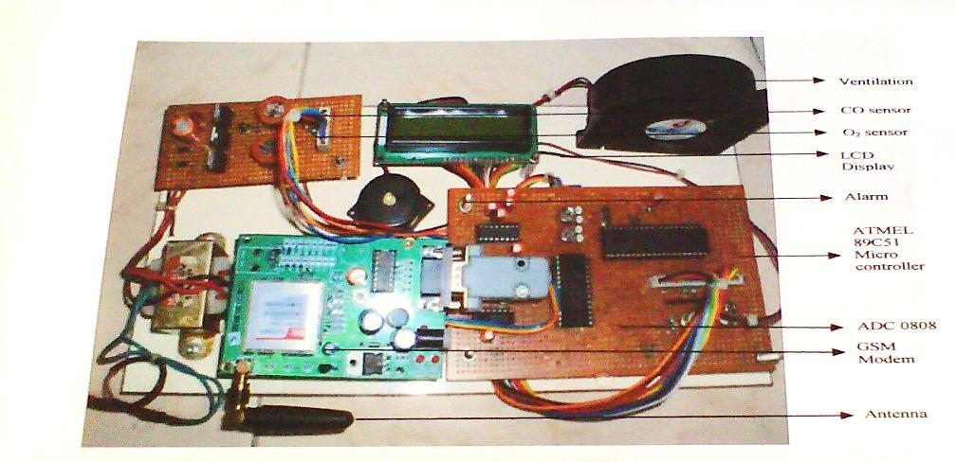

Figure 8: Prototype of the proposed system

**4.** **CONCLUSION**

An embedded system is designed and tested for toxic gas detection inside a vehicle cabin using ATMEL 89C51 microcontroller. Toxic gas like CO is less sensible by human which endangers the human lives. This critical situation can be avoided by implementing the sensors for sensing the level of CO and oxygen level and is displayed every second. When the Co level exceeds normal level that is CO is greater than 30ppm and if the Oxygen level decreases below the normal level of 19ppm then the designed system provides an alarm and also the warning message to the authorized user. Ventilation is immediately provided in the cabin, whenever this critical situation occurs. This prototype can also be used at Home; Educational and working institutions for monitoring the indoor air quality which intern enhance the quality of working environment.

**REFERENCES**

1. A.R.Ali, E. Imran Zualkerman, and Fadi Aloul, “A Mobile GPRS-Sensors Array for Air Pollution Monitoring”, vol. 8, pp. 415-422, 2010.
2. F.-S. Bai, Y.-L. Liu, “Design of Fault Monitoring Alarm System for Networks Based on GSM SMS,” pp. 45-67, 2010.
3. Al-Ali, member, IEEE, Imran Zualkerman, and Fadi Aloul, “A Mobile GPRS-Sensors Array for Air Pollution Monitoring”, vol. 6,pp. 410-422, Oct.2010.
4. Da-Jeng Yao,“A gas sensing system for indoor air quality control and polluted environment monitoring ”, pp. 11-14, 2009.
5. W. Chung and C. H.Yang, “Remote monitoring system with wireless sensors module for room environment,” Sens. Actuators B, vol. 113, no. 1, pp. 35–42, 2009.
6. F. Tsow, E Forzani, A. Rai, R. Wang, R. Tsui, S. Mastroianni, C. Knobbe, A. J. Gandolfi, and N. J. Tao, “A wearable and wireless sensor system for real-time monitoring of toxic environmental volatile organic compounds,” IEEE Sensors J., vol. 9, pp. 1734–1740, Dec. 2009.
7. Chen Peijiang, Jiang Xuehua, “Design and implementation of Remote monitoring system based on GSM”, vol. 42, pp. 167-175, 2008.
8. LIU Zhen-ya, Wang zhen-dong, Chen Rong, “Intelligent Residential Security Alarm and Remote Control System Based on Single Chip Computer”, vol. 42, pp.143-166, 2008.
9. N. Kularatna and B. H. Sudantha, “An environmental air pollution monitoring system based on the IEEE 1451 standard for low cost
10. Ben Gaid, M.; Kocik, R.; Sorel, Y.; Hamouche, R. A methodology for improving software design lifecycle in embedded control systems. In Proc. of Design, Automation and Test in Europe (DATE), Munich, Germany, March 2008.
11. Y. J. Jung, Y. K. Lee, D. G. Lee, K. H. Ryu, and S. Nittel, “Air pollution monitoring system based on

geosensor network,” in Proc. IEEE Int. Geoscience Remote Sensing Symp., 2008, vol. 3, pp. 1370– 1373.

[12 ]M. Gao, F. Zhang, and J. Tian, “Environmental monitoring system with wireless mesh network based on embedded system”, in Proc. 5th IEEE Int. Symp. Embedded Computing, 2008, pp. 174-179.

13] J. W. Kwon, Y. M. Park, S. J. Koo, and H. Kim, “Design of air pollution monitoring system using ZigBee networks for ubiquitous-city,” in Proc. Int. Conf. Convergence Information Technology, 2007, pp. 1024–1031.

1. Ruijie Zhang Funjun He, Zhijiang Du and Lining Sun, “An Intelligent Home Environment Inspecting Robot”, vol. 42, pp.140-169, 2007.
2. H.-M. Tsai, C. Saraydar, T. Talty, M. Ames, A. Macdonald, and O. Tonguz, “Zigbee-based intra-car wireless sensor network,” in Proc.IEEE Int. Conf. on Communications (ICC’07), June 2007, pp. 3965–3971.