Effect of EBG Presence on Elliptical

Patch Antenna

**T maheshwar1, ch shekar2, p aruna3**

**1,2,3 Department of Electronics and communication Engineering,SreeDattha Institute of Engineering & Science**

**Abstract:**

The Paper demonstrates the design and performance of Elliptical Patch antenna in presence of EBG structureat one of its sides and its performance is compared with conventional type under similar design conditions. Here the designed Elliptical Patch antenna has a major radius 4 and ratio 30. And EBG designed as single layer of one array of patches for EBG and having 0.5cm pillar height patch size of 2cm side length square shape patches with 0.2cm gap. Conventional antenna operated at a frequency of 2.6608GHz and in presence of EBG it works at 2.6683GHz Frequency and the comparative analysis is illustrated in this paper.

**Keywords**: Energy Band gap Structure (EBG), Surface Wave Suppression, Radiation Enhancement, improved gain.

**I.INTRODUCTION**

The micro strip patch antennas have their various advantages in wireless communication applications because of their low cost manufacturing, compatibility with low size, and these micro strip antennas are low profile antennas. But still these antennas have narrow band width and its radiation enhancement is much needed for improvisation of its usage in our communication applications. Here I use EBG structures to enhance the antenna parameters. Generally the EBG structures mainly suppresses the surface wave propagations many researches concentrated on using this EBG in various methods to enhance the antenna parameters and to check its effects on Conventional antennas here in this paper we analyse the Elliptical Patch antenna and compare its radiation pattern width, gain directivity, intensity, front to back ratio and Radiation efficiency with conventional type.

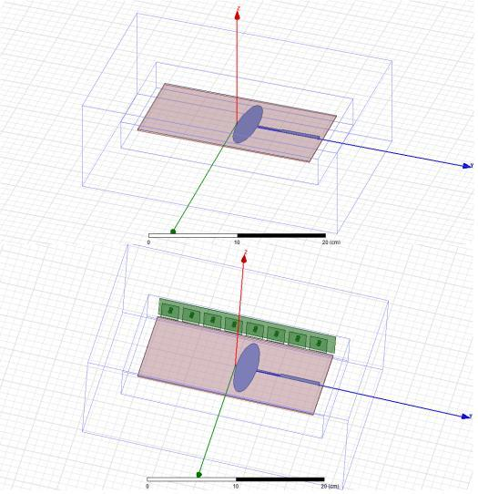

Fig [1]. Conventional and Designed antenna

**II. ANTENNA AND EBG DESIGNS**

**1.1. Antenna**

Here the same elliptical patch antenna is used for the analysis on same substrate under same execution conditions. The designs or shown in the below figure [1]. And the antenna is fed with micro-strip feed from wave port for excitation.

**1.2. EBG structure**

The EBG design is explained by the following figure [2]. And the EBG unit cell design and explains its working how it exhibiting high impedance

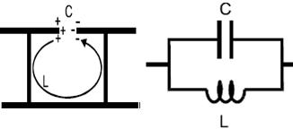

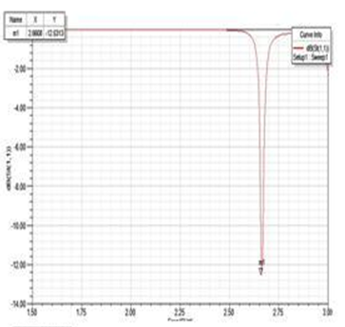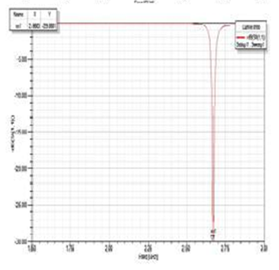

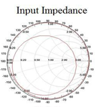 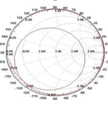

Figure [2]. EBG unit cell and its equivalent

**III. SIMULATION RESULTS**

**3.1 Return loss**

The return loss curves for the conventional and designed antenna are illustrated in the below figure [3] and by the figure [3] the operating frequencies are 2.6608GHz and 2.6683GHz for conventional and test antennas. And it is also seen that the return loss for conventional antenna is -12.5313dB and for antenna with EBG is - 29.8881dB by the comparison of return loss values I can say that the surface wave propagation or the loss due to surface waves is suppressed due to the presence of EBG and the return loss is very much improved.

**3.2 Input Impedance**

The both antennas are implemented under the same input impedance of 5Ω and the input impedance curves are shown in the following figure [4].

**3.3 Radiation Patterns**

The Radiation patterns in phi and theta directions for both conventional and designed antenna are illustrated in the figure [5] and [6]. And the change in radiation patterns are observed form theta direction because the EBG is placed at on side so its effects can be seen easily from top view. The 3D gain curves can explain the radiation enhancement and the improvement in gain. Comparative gain plots are illustrated in the figure [7].

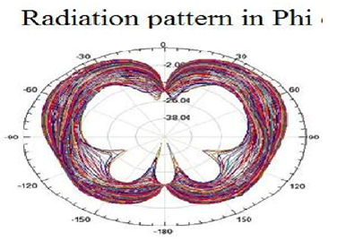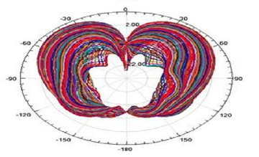

Figure [6] Radiation pattern in Theta direction D. *3D- Gain*

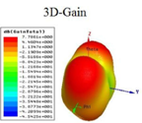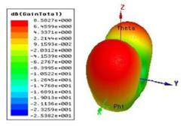

Figure [7] Gain in 3D plots (a) normal antenna (b) Antenna with EBG direction D. *3D- Gain*

Form the above figure [7] (a) I can explain that the conventional type have energy distribution in back ward direction which is reduced in (b) and form the above figure data I can also seen that the maximum gain value in 7(a) is 7.7861 which is enhanced to 9.1593 in 7(b) so that from this results I can conclude that the effect of EBG on antenna improves its performance.

**IV. ANTENNA PARAMETERS**

By the simulated data we are listing some antenna parameters comparison in the below table [1]

Table [1]. Antenna parameters

|  |  |  |  |
| --- | --- | --- | --- |
| **Quantity** |  | **Value** | |
| Max U | 0.00114143 |  | 0.00199301 |
|  | (W/sr) |  | (W/sr) |
| Peak Directivity | 6.98302 |  | 8.01318 |
|  |  |  |  |
| Peak Gain | 6.00636 |  | 7.21552 |
| Peak Realized | 1.43439 |  | 2.50455 |
| Gain |  |  |  |
| Radiated Power | 0.00205411 |  | 0.00312553 |
|  | (W) |  | (W) |
| Accepted Power | 0.00238812 |  | 0.00347106 |
|  | (W) |  | (W) |
| Incident Power | 0.01 |  | 0.01 |
|  | (W) |  | (W) |
| Radiation | 0.860137 |  | 0.900456 |
| Efficiency |  |  |  |
| Front to Back | 6.28365 |  | 11.8012 |
| Ratio |  |  |  |

From above table [1] I can explain that all the parameters of conventional antenna are improved due to the presence of EBG. The presence of EBG improved peak gain and directivity form 6.98302, 6.00636 to 8.01318, 7.21552 respectively and the radiation efficiency also improved to 90% from 86%.

V. **CONCLUSION**

I can conclude that the presence of EBG have improved the performance of designed Elliptical micro strip patch antenna mainly its gain and radiation are improved and there is small improvement in its band width too. So this is very useful for wireless communication application to enhance the antenna parameters for effective utilization.

**REFERENCES**

1. J. Doondi kumar , “Analysis of Monopole Antenna by Placing High Impedance Absorber Surface at one Side” /Volume-2Number-1PP-317-321.pdf
2. J. Doondi kumar , “Design and Analysis of C0-axial Feed Rectangular Patch Antenna on High Impedance Surface” /Volume-2Number-1PP 405-410.pdf
3. D. Sievenpiper, “High - Impedance EM surfaces”, Ph.D. Dissertation, University of California, Los Angeles, 1999.
4. D. Sievenpiper, E. Yablonovitch, U.S. provisional patent application, serial number 60/079953, filed on March 30,1998.
5. Hashmi RM, Siddiqui AM, Jabeen M, Shehzad K, Abbas SM and Alimgeer KS, “Design and Experimental Analysis of High Performance Microstrip Antenna”, International Journal of Computer and Network Security, vol. 1, no. 3, (2009) December.
6. Yang, F. and Y. Rahmat-Samii, \Microstrip antennas integrated with electromagnetic band-gap (EBG) structures: A low mutual coupling design for array applications," IEEE Transactions on Antennas and Propagation, Vol. 51, No. 10, 2936{2946, Oct. 2003.
7. Sievenpiper, D. F., \High-impedance electromagnetic surfaces," Doctorate thesis, University of California, 1999.
8. Sievenpiper, D, F., \Review of theory fabrication and applications of HIS ground planes," Metamaterials: Physics and Engineering, Explorations,Chap. 11, 287{311, Edited by N. En- gheta and R. Ziolkowski, Wiley Interscience, 2006
9. Yang, F. and Y. Rahmat-Samii, “Step-like structure and EBG structure to improve the performance of patch antennas on high dielectriion substrate,” Proc. IEEE AP-S Dig., Vol. 2, 482–485, July 2001.
10. C. Balanis, Antenna theory, Analysis, and Design 2nd ed., John Wiley and sons, New York (1997)