Semantic Analysis and Representation of Medical Images using Hybrid Watershed algorithm

Dr.Pandarinath Potluri¹, P.Prashant Kumar², Muneer Ahmed³
^{1,2,3}(Computer Science and Engineering, Sree Dattha Institute of Engineering & Science)

Abstract: In this paper, a learning approach coupling region based and content based image processing is presented for Semantic image analysis in medical domain. Explicitly defined domain knowledge under the proposed approach includes objects of the domain of interest and their spatial relations based on the training set. The proposed algorithm contains 3 levels namely Annotation, Region analysis and Graphical representation. Finally the images are represented as graphs. Annotation is to find the organs present in the image and Region analysis is to find the dissimilarities. The abnormal conditions are clearly noted and revealed in graphs. The efficiency of graph is increased by the providing more information about the discrepancies. This gives the exact information what user requires and helps in easier understanding of Medical images.
Keywords - Semantic Analysis, Annotating Images, Edge Detection, Graphical image representation, Medical image analysis.

INTRODUCTION
Semantic Analysis is the concept of analysing an image semantically based on the contents of the image (i.e.) data based on the image. Analysis of the image is the process of retrieving the data from the image using various techniques such as Histogram processing [1], Image correlation[1], Image segmentation [1] etc. Most of the techniques evaluate the features or characteristics of the image as output.
Most frequently used analysis method is the Comparison method. Here the input image is compared with the images in the database and the similarities and dissimilarities are identified. Based on the results the input is grouped or stored in the database in such a manner that extracting the information from database is easier. Image comparison is done based on many techniques such as Segmentation analysis [1],
Annotation based, Set based hybrid approach (SHA) for image segmentation, Edge detection techniques etc. In the proposed model the image is compared using annotation technique and then watershed algorithm is applied after edge detection. Annotation of image is to find the objects in the image and the image is compared using edge detection to find the abnormal behaviour (i.e.) dissimilar parts of the image. Combining the above two results and comparing with the standard data, a graph is drawn with the information like, what organs are present, what are the defects in the organs, where are they and some technical data about the defects.
The paper is organized as follows. The next section describes the related work contributed prior by others. Section III gives a brief description about the System architecture. Section IV goes into detail on each of the building blocks in the proposed framework. Section V explains the working process with sample outputs of the proposed model. Finally, Section VI concludes and discusses ideas for future work.

RELATED WORK
Many researches are done in the field of Image processing in various areas. The major areas concentrated are Annotation and Segmentation Analysis. Annotation of an image describes the Image by providing the name of the objects present in the image.Manual annotation is a more reliable process but it is tedious because it needs more human resource and time. So Auto-Annotation process is chosen. But the efficiency of the process can’t be similar to manual annotation. One of the methods used is Latent Semantic Analysis
- Training step: the annotated images are segmented and compared and then once again grouped in blobs that are annotated.
- New image processing step: the input image will be segmented and annotated by the key words of the blobs to which the regions belong to.

Another approach for Annotation is Automatic Image Annotation by Ensemble of Visual Descriptors [3]. A way to reduce the effects of Normalization and Redundancy is to study number of visual properties of the whole image. For this purpose, a two-layer collaborative learning system, called Supervised Annotation by Descriptor Ensemble (SADE), is proposed. SADE, initially, extracts a range of low-level visual descriptors from the image. Each descriptor is, then, fed to a separate learning machine in the first layer. Finally, the meta-layer classifier is trained on the output of the first layer classifiers.
Automatic image Annotations’ accuracy can be enhanced based on the word co-occurrence method [4]. K−nearest neighbours (KNN) classifier is used to rank the group of candidate tags for a given object. Naïve Bayes Improver based on Co-occurrences (NBIC) is used to enhance the performance based on Relevance weight since in NBIC this weight is used as prior probabilities for the tags. Prior probabilities for NBIC, should met the following: 1) they should imitate the sureness of the annotation method and 2) the weight for the top−k candidate tags should sum unity.
Another method to improve Auto-Annotation is given by es of the given image and the images on dataset. The distances of the various pixels and the neighbourhood pixels contribute on the feature distance. The scaled distance and the training set data are compared for the labelling process. Here distances are determined by Joint Equal Contribution and Lasso methods. After the comparison the similar images are tagged with the keywords in the sample database.
Semantic analysis is the analysing of the meaning of the data and not based on the content viewable by the user. In images the meaning of the image denotes the data about the objects present in the image.
A method using Nonnegative Matrix Factorization [6] is introduced by Angel Cruz-Roa, Gloria Díaz, Fabio González. The model proposed uses Bag of Features (BOF) to represents the visually obtainable informationof a histopathology image collection and Convex Nonnegative Matrix Factorization (CNMF) is applied to a training set of images to discover a close representation by dividing the matrix into clusters of semantics and membership values of images in latent topic space.
Watershed algorithm and Fast region merging [7] are united to give Hybrid image segmentation. Initial partitioning of the image into primitive regions is produced by applying the watershed transform and given as input to a computationally efficient hierarchical region merging process that produces the final segmentation. At each step, the most similar pair of regions is determined, regions are merged.
For segmenting the Medical images like MRI images a Set based Hybrid Approach (SHA) [8] is used. The proposed model combines two techniques namely region-grow and threshold level set. Region-grow algorithm starts with a seed on the feature of interest in the image and expanding the area by adding the neighbourhood pixels which are similar. Level set is a boundary based segmentation technique which is performed later. Hybrid approach combines the results like a set union as final result.
To bridge the semantic gap between the images’ low- level visual features and the high-level semantic concepts, an image semantic representation model (ISRM) was proposed based on statistical learning theory and smooth support vector regression (SSVR)[10]. This model consists of primitive image set, image feature set, image semantic set, semantic rule set and semantic mappings. The example-based high-level semantic retrieval algorithm (EHSR) and the text-based high-level semantic retrieval algorithm (THSR) for image retrieval using high-level semantic content were designed and implemented respectively.
Representing the Medical image as a graph is done to make the user to focus on the information that is only needed to him. The needed information is determined by finding the objects present in the image that are not similar.
One of the method to represent the image as tree structured graph [9] is done by Anastasios D. Doulamis, Nikolaos D. Doulamis and Stefanos D. Kollias. The basic concept is to map the spatial relations of the image objects with an image-graph and then, the object details with an object-graph. Image graph and object graph subsystems are created based on the colour hierarchy of the image.

SYSTEM ARCHITECTURE
The system architecture is given below in a diagrammatic way for easier understanding. The training set consists of manually annotated images for comparison purpose. Training set is annotated by the human for the reliability of the training set and the reliability of the Auto-Annotation module because AA module annotates images based on the manually annotated images in the training dataset.
The input image is a raw medical image. It is compared with the training set images and annotation is done based on the correlation[1] and histogram analysis[1]. The objects are identified in the annotation process. The dissimilarities are discovered by the combination of edge detection technique [1] and image segmentation technique. The discovered dissimilarities are then localised. The data obtained in these modules are then scrutinized to represent as a graph in the hierarchical structure.

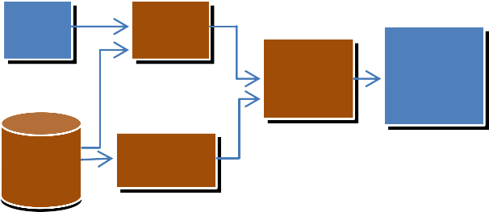
Raw
image
Annotat
ion
Scrutinizin
g
Image
Representati on
Training
set
Semantic
Region Analysis
Fig1: Overall architecture of the System
Graph representation is much better view because it deals with the abnormal behaviour only and the normal behaviours are not given much importance.

BUILDING BLOCKS
The whole process is divided into 4 distinct modules. Here the medical images are used in the experimental studies of the proposed framework. The modules are
- Auto-Annotation module
- Semantic Region Analysis
- Data Scrutinizing Module
- Representation Module

Auto-Annotation module
The AA module performs the annotation process (i.e.) given the description of the image, based on the histogram analysis and the image correlation after comparing with the training set images.
The histogram analysis is done for the same gray level images because same images of different gray level images have a high degree of variation. By default MRI images have same gray levels, which is an advantage to the analysis process.
Image correlation is done on any two images which will give high degree of similarity for the visually similar images. Based on the results of the two processes the image is annotated (i.e.) the manual annotation given to the most similar image is copied to the input image.

Region Analysis module
Semantic region analysis is done to identify the dissimilar regions in the image. Most of the normal images of the organs are in our dataset. So the dissimilar region indicates that the organs are in abnormal conditions. Region analysis is done using edge detection algorithm and watershed algorithm.
Edge detection is done to find the edges in the image and then comparison of images based on the edges is done. The dissimilar images are the processed by watershed algorithm to distinguish the dissimilar regions. For edge detection canny algorithm is used because it can also find out the inner edges of all objects in the image.

Data scrutinizing module
Data retrieved from the image in the above two steps are combined into one to represent it in a graph, more easier way of representation. Combining the information means converting the all retrieved data in a clear format (i.e.) user understandable format like listing all the objects present in the image, locating the dissimilar region and the visually similar data about the dissimilar region like size, shape etc.
The data to be displayed in the graph will be user understandable. But the data obtained from the above step is a computer understandable form of data like some mathematical values. So a separate function is used to map the data obtained from the image processing steps to the correct form of data understandable by the user.

Representation module
Graph will explain only the problems that are in the image which is given as the input. All other normal regions are not mentioned clearly.
Names of the objects in the image are taken as the nodes and the details about the dissimilar objects are given child nodes to the appropriate nodes. Nodes with child are the ones that are of importance. Data about the dissimilarity means how it is dissimilar, where it is located, what may be the cause etc. These all are obtained from the table having the cause for the most common problems due to the dissimilar regions.

WORKING METHODOLOGY
The input image is compared with the training set image one by one using the image correlation technique. The percentage of similarity is saved on a variable. Histogram analysis is also done and the comparison similarity is stored in another variable. Based on the values in the two variables the annotation of the image is done (i.e.) the annotation of the image which is most similar is copied to the given input image.
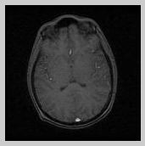
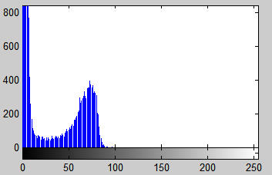

Fig2: Input and output of Histogram processing

For region analysis edge detection is first done and the output of this process is compared for finding the dissimilar region. Then the region is distinguished by watershed algorithm. For edge detection canny algorithm is used.

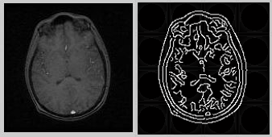
Fig3: Input and output of canny algorithm

Watershed algorithm highlights all separate regions in the image. Based on this algorithm the appropriate location of the dissimilar region is identified.

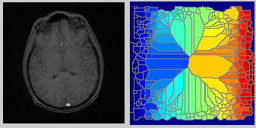
Fig4: Input and output of watershed algorithm

Results of the above two steps are combined to represent the image in a graph structure. The annotation gives the names of the objects that present in the image which acts as nodes. The dissimilar region is indicated as the child node with data like appropriate location, size of the object etc.
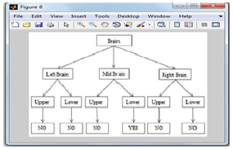

CONCLUSION AND FUTURE WORK
Our proposed model reduces the work of Medical practitioner to analyze the image and also increases the accuracy. Our approach is done as an initiative. So it concentrates on MRI images of Brain only. As a success of proposed model, the approach can be extended to all Medical images of various organs.
Advanced techniques can be employed to increase the functionalities of the model such as suggesting the appropriate consultants, summarize all the results for specific patients etc.

REFERENCES
- Rafael C.Gonzalez and Richard E.Woods, Digital Image Processing Fourth edition, Pearson Education, 2009.
- MahdiaBakalem, NadjiaBenblidia, SalihaOukid, Latent Semantic Analysis-based Image Auto Annotation. In IEEE conference proceedings, pp. 460-463, March 2010.
- Akbas, E.; YarmanVural, F.T.; Middle East Tech. Univ., Ankara , Automatic Image Annotation by Ensemble of Visual Descriptors, In IEEE conference Computer Vision and Pattern Recognition, CVPR '07, pp. 1-8, 2007.
- H. Jair Escalante, Manuel Montes, and L. Enrique Sucar, Improving Automatic Image Annotation Based on Word Co-occurrence. In IEEE ISCIS’08 proceedings, pp. 1-4.
- AmeeshMakadia, Vladimir Pavlovic, and Sanjiv Kumar, A New Baseline for Image Annotation, In Computer Vision ECCV 2008, pp. 316-329.
- Angel Cruz-Roa, Gloria Díaz, Fabio González, A Framework for Semantic Analysis of Histopathological Images Using Nonnegative Matrix Factorization, IEEE conference 2011, pp. 1-7.
- Kostas Haris, Serafim N. Efstratiadis, NicosMaglaveras and Aggelos K. Katsaggelos, Hybrid Image Segmentation Using Watersheds and Fast Region Merging, IEEE transactions on image processing, vol. 7, no. 12, pp. 1684-1699 dec 1998.
- Jiang. Liu, Tze-Yun LeongP, Kin Ban CheeP, Boon Pin TanP, A Set-based Hybrid Approach (SHA) for MRI Segmentation, ICARCV., pp. 1-6, 2006.
- Anastasios D. Doulamis, Nikolaos D. Doulamis and Stefanos D. Kollias, Representation of Image Content Using Tree-Structured Graphs, IEEE conference, pp.1-6.
- Xin Zhang, Bing Wang, Zhi-De Zhang, Xiao- Yan Zhao, SSVR-based image semantic retrieval, Seventh International Conference on Machine Learning and Cybernetics, pp. 2607- 2611, 12-15 July 2008.

