Mona: Secure Multi-Owner Data Sharing for Dynamic Groups in the Cloud

*Dr Tirumala Rao.K,**Mr. L.NARESH,*** J.Raja Ram
*,**,*** Computer Science Engineering Dept,Sree Dattha Institute of Engineering & Science

Abstract: With the character of low maintenance, cloud computing provides an economical and efficient solution for sharing group resource among cloud users. Unfortunately, sharing data in a multi-owner manner while preserving data and identity privacy from an un trusted cloud is still a challenging issue, due to the frequent change of the membership. In this paper, we propose a secure multi owner data sharing scheme, named Mona, for dynamic groups in the cloud. By leveraging group signature and dynamic broadcast encryption techniques, any cloud user can anonymously share data with others. Meanwhile, the storage overhead and encryption computation cost of our scheme are independent with the number of revoked users. In addition, we analyze the security of our scheme with rigorous proofs, and demonstrate the efficiency of our scheme in experiments.

- INTRODUCTION
Cloud computing is the use of computing resources (hardware and software) that are delivered as a service over a network (typically the Internet). The name comes from the common use of a cloud-shaped symbol as an abstraction for the complex infrastructure it contains in system diagrams. Cloud computing entrusts remote services with a user's data, software and computation. Cloud computing consists of hardware and software resources made available on the Internet as managed third-party services. These services typically provide access to advanced software applications and high-end networks of server computers.
The goal of cloud computing is to apply traditional supercomputing, or high-performance computing power, normally used by military and research facilities, to perform tens of trillions of computations per second, in consumer-oriented applications such as financial portfolios, to deliver personalized information, to provide data storage or to power large, immersive computer games.
Cloud computing is recognized as an alternative to traditional information technology due to its intrinsic resource-sharing and low-maintenance characteristics. In cloud computing, the cloud service providers (CSPs), such as Amazon, are able to deliver various services to cloud users with the help of powerful datacenters. By migrating the local data management systems into cloud servers, users can enjoy high-quality services and save significant investments on their local infrastructures.
One of the most fundamental services offered by cloud providers is data storage. Let us consider a practical data application. A company allows its staffs in the same group or department to store and share files in the cloud. By utilizing the cloud, the staffs can be completely released from the troublesome local data storage and maintenance. However, it also poses a significant risk to the confidentiality of those stored files. Specifically, the cloud servers managed by cloud providers are not fully trusted by users while the data files stored in the cloud may be sensitive and confidential, such as business plans. To preserve data privacy, a basic solution is to encrypt data files, and then upload the encrypted data into the cloud. Unfortunately, designing an efficient and secure data sharing scheme for groups in the cloud is not an easy task due to the following challenging issues.
First, identity privacy is one of the most significant obstacles for the wide deployment of cloud computing. Without the guarantee of identity privacy, users may be unwilling to join in cloud computing systems because their real identities could be easily disclosed to cloud providers and attackers. On the other hand, unconditional identity privacy may incur the abuse of privacy. For example, a misbehaved staff can deceive others in the company by sharing false files without being traceable. Therefore, traceability, which enables the group manager (e.g., a company manager) to reveal the real identity of a user, is also highly desirable.
Second, it is highly recommended that any member in a group should be able to fully enjoy the data storing and sharing services provided by the cloud, which is defined as the multiple-owner manner. Compared with the single-owner manner, where only the group manager can store and modify data in the cloud, the multiple-owner manner is more flexible in practical applications. More concretely, each user in the group is able to not only read data, but also modify his/her part of data in the entire data file shared by the company.
Last but not least, groups are normally dynamic in practice, e.g., new staff participation and current employee revocation in a company. The changes of membership make secure data sharing extremely difficult. On one hand, the anonymous system challenges new granted users to learn the content of data files stored before their participation, because it is impossible for new granted users to contact with anonymous data owners, and obtain the corresponding decryption keys. On the other hand, an efficient membership revocation mechanism without updating the secret keys of the remaining users is also desired to minimize the complexity of key management.
Several security schemes for data sharing on un trusted servers have been proposed. In these approaches, data owners store the encrypted data files in un trusted storage and distribute the corresponding decryption keys only to authorized users. Thus, unauthorized users as well as storage servers cannot learn the content of the data files because they have no knowledge of the decryption keys.
However, the complexities of user participation and revocation in these schemes are linearly increasing with the number of data owners and the number of revoked users, respectively. By setting a group with a single attribute, Lu et al. Proposed a secure provenance scheme based on the cipher text-policy attribute-based encryption technique, which allows any member in a group to share data with others. However, the issue of user revocation is not addressed in their scheme. Yu et al. presented a scalable and fine-grained data access control scheme in cloud computing based on the key policy attribute-based encryption (KP-ABE) technique. Unfortunately, the single- owner manner hinders the adoption of their scheme into the case, where any user is granted to store and share data.
To solve the challenges presented above, we propose Mona, a secure multi-owner data sharing scheme for dynamic groups in the cloud. The main contributions are:
- A secure multi-owner data sharing scheme. It implies that any user in the group can securely share data with others by the un trusted cloud is proposed.
- It is able to support dynamic groups efficiently. Specifically, new granted users can directly decrypt data files uploaded before their participation without contacting with data owners. User revocation can be easily achieved through a novel revocation list without updating the secret keys of the remaining users. The size and computation overhead of encryption are constant and independent with the number of revoked users.
- To provide secure and privacy-preserving access control to users, which guarantees any member in a group to anonymously utilize the cloud resource? Moreover, the real identities of data owners can be revealed by the group manager when disputes occur.
- A rigorous security analysis, and perform extensive simulations to demonstrate the efficiency of our scheme in terms of storage and computation overhead is provided.

- LITERATURE SURVEY
- Scalable Secure File Sharing on Untrusted Storage.
Plutus is a cryptographic storage system that enables secure file sharing without placing much trust on the file servers. In particular, it makes novel use of cryptographic primitives to protect and share files. Plutus features highly scalable key management while allowing individual users to retain direct control over who gets access to their files. We explain the mechanisms in Plutus to reduce the number of cryptographic keys exchanged between users by using file groups, distinguish file read and write access, handle user revocation efficiently, and allow an un trusted server to authorize file writes. We have built a prototype of Plutus on Open AFS.
- Securing Remote Untrusted Storage
This paper presents SiRiUS, a secure file system designed to be layered over insecure network and P2P file systems such as NFS, CIFS, Ocean Store, and Yahoo! Briefcase. SiRiUS assumes the network storage is untrusted and provides its own read-write cryptographic access control for file level sharing. Key management and revocation is simple with minimal out-of-band communication. File system freshness guarantees are supported by SiRiUS using hash tree constructions. SiRiUS contains a novel method of performing file random access in a cryptographic file system without the use of a block server. Extensions to SiRiUS include large scale group sharing using the NNL key revocation construction. Our implementation of SiRiUS performs well relative to the underlying file system despite using cryptographic operations.
- Improved Proxy Re-Encryption Schemes with Applications to Secure Distributed Storage
In 1998, Blaze, Bloomer, and Strauss (BBS) proposed an application called atomic proxy re-encryption, in which a semi trusted proxy converts a cipher text for Alice into a cipher text for Bob without seeing the underlying plaintext. We predict that fast and secure re-encryption will become increasingly popular as a method for managing encrypted file systems. Although efficiently computable, the wide-spread adoption of BBS re-encryption has been hindered by considerable security risks. Following recent work of Dodis and Ivan, we present new re-encryption schemes that realize a stronger notion of security and demonstrate the usefulness of proxy re-encryption as a method of adding access control to a secure file system. Performance measurements of our experimental file system demonstrate that proxy re-encryption can work effectively in practice.

- the Essential of Bread and Butter of Data Forensics in Cloud Computing
Secure provenance that records ownership and process history of data objects is vital to the success of data forensics in cloud computing, yet it is still a challenging issue today. In this paper, to tackle this unexplored area in cloud computing, we proposed a new secure provenance scheme based on the bilinear pairing techniques. As the essential bread and butter of data forensics and post investigation in cloud computing, the proposed scheme is characterized by
Providing the information confidentiality on sensitive documents stored in cloud, anonymous authentication on user access, and provenance tracking on disputed documents. With the provable security techniques, we formally demonstrate the proposed scheme is secure in the standard model.

- An Expressive, Efficient, and Provably Secure Realization.
We present a new methodology for realizing Ciphertext-Policy Attribute Encryption (CP-ABE) under concrete and no interactive cryptographic assumptions in the standard model. Our solutions allow any encrypter to specify access control in terms of any access formula over the attributes in the system. In our most efficient system, cipher text size, encryption, and decryption time scales linearly with the complexity of the access formula. The only previous work to achieve these parameters was limited to a proof in the generic group model.
We present three constructions within our framework. Our first system is proven selectively secure under an assumption that we call the decisional Parallel Bilinear Diffie-Hellman Exponent (PBDHE) assumption which can be viewed as a generalization of the BDHE assumption. Our next two constructions provide performance tradeoffs to achieve provable security respectively under the (weaker) decisional Bilinear-Diffie-Hellman Exponent and decisional Bilinear Diffie-Hellman assumptions.

- SYSTEM DESIGN
- .Existing System
To preserve data privacy, a basic solution is to encrypt data files, and then upload the encrypted data into the cloud. Unfortunately, designing an efficient and secure data sharing scheme for groups in the cloud is not an easy task.
The data owners store the encrypted data files in untrusted storage and distribute the corresponding decryption keys only to authorized users. Thus, unauthorized users as well as storage servers cannot learn the content of the data files because they have no knowledge of the decryption keys. However, the complexities of user participation and revocation in these schemes are linearly increasing with the number of data owners and the number of revoked users, respectively.
Disadvantages of Existing System
- Identity privacy is one of the most significant obstacles for the wide deployment of cloud computing. Without the guarantee of identity privacy, users may be unwilling to join in cloud computing systems because their real identities could be easily disclosed to cloud providers and attackers.
- On the other hand, unconditional identity privacy may incur the abuse of privacy. For example, a misbehaved staff can deceive others in the company by sharing false files without being traceable.
- Only the group manager can store and modify data in the cloud.
- The changes of membership make secure data sharing extremely difficult the issue of user revocation is not addressed.

- Proposed System
A secure multi-owner data sharing scheme is provided. It implies that any user in the group can securely share data with others by the un trusted cloud. Our proposed scheme is able to support dynamic groups efficiently. Specifically, new granted users can directly decrypt data files uploaded before their participation without contacting with data owners. User revocation can be easily achieved through a novel revocation list without updating the secret keys of the remaining users. The size and computation overhead of encryption are constant and independent with the number of revoked users.
A secure and privacy-preserving access control to users, which guarantees any member in a group to anonymously utilize the cloud resource, is provided. Moreover, the real identities of data owners can be revealed by the group manager when disputes occur. A rigorous security analysis, and perform extensive simulations to demonstrate the efficiency of our scheme in terms of storage and computation overhead.

Advantages of Proposed System
- Any user in the group can store and share data files with others by the cloud.
- The encryption complexity and size of cipher texts are independent with the number of revoked users in the system.
- User revocation can be achieved without updating the private keys of the remaining users.
- A new user can directly decrypt the files stored in the cloud before his participation.

- IMPLEMENTATION.
Implementation is the stage of the project when the theoretical design is turned out into a working system. Thus it can be considered to be the most critical stage in achieving a successful new system and in giving the user, confidence that the new system will work and be effective.
The implementation stage involves careful planning, investigation of the existing system and it’s constraints on implementation, designing of methods to achieve changeover and evaluation of changeover methods.
Module Description
4.1 Cloud Module
In this module, we create a local Cloud and provide priced abundant storage services. The users can upload their data in the cloud. We develop this module, where the cloud storage can be made secure. However, the cloud is not fully trusted by users since the CSPs are very likely to be outside of the cloud users’ trusted domain. Similar to we assume that the cloud server is honest but curious.

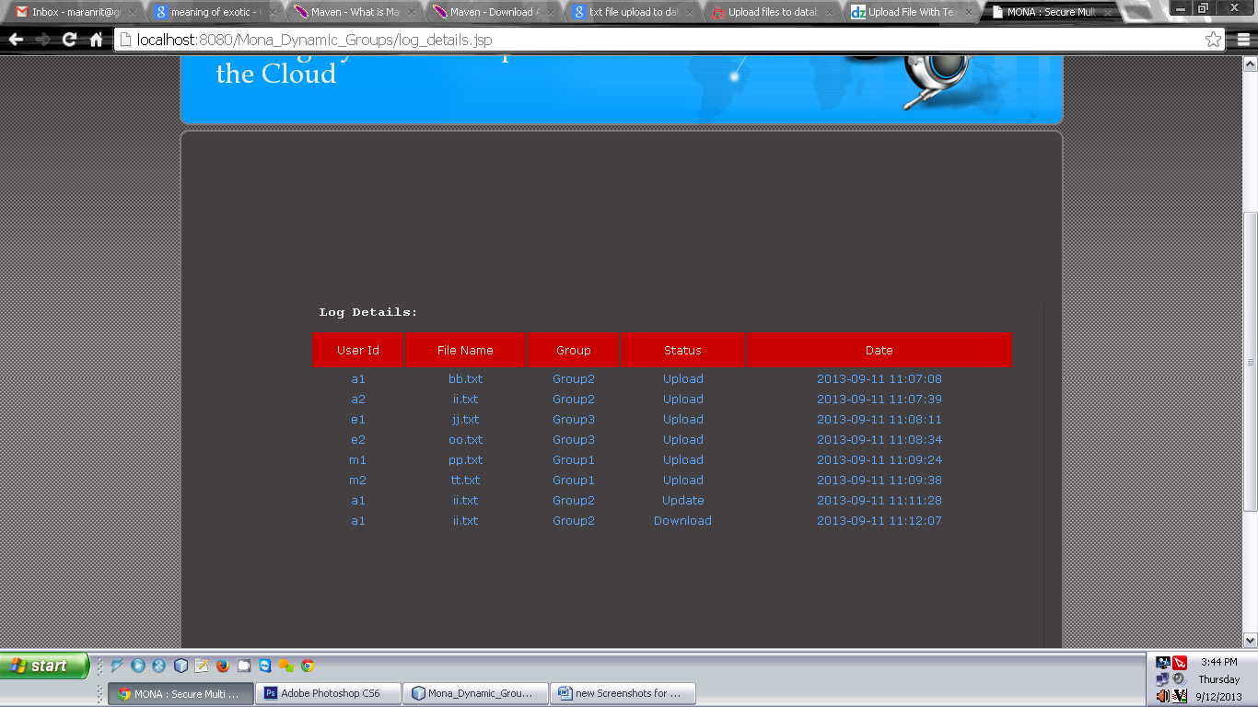

That is, the cloud server will not maliciously delete or modify user data due to the protection of data auditing schemes, but will try to learn the content of the stored data and the identities of cloud users.
4.2 Group Manager Module
Group manager takes charge of followings,
1. System parameters generation,
2. User registration,
3. User revocation, and
4. Revealing the real identity of a dispute data owner.
Therefore, we assume that the group manager is fully trusted by the other parties.

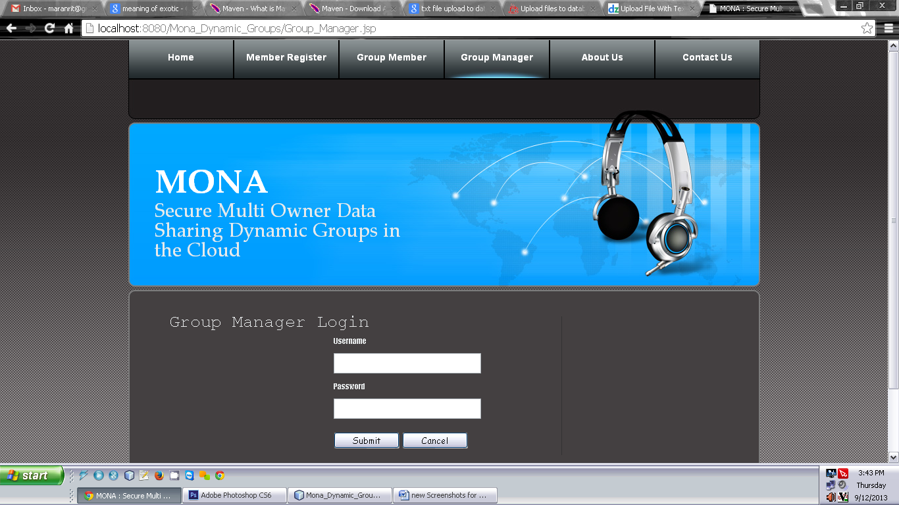
The Group manager is the admin. The group manager has the logs of each and every process in the cloud. The group manager is responsible for user registration and also user revocation too.

4.3 Group Member Module
Group members are a set of registered users that will
- store their private data into the cloud server and
- Share them with others in the group.

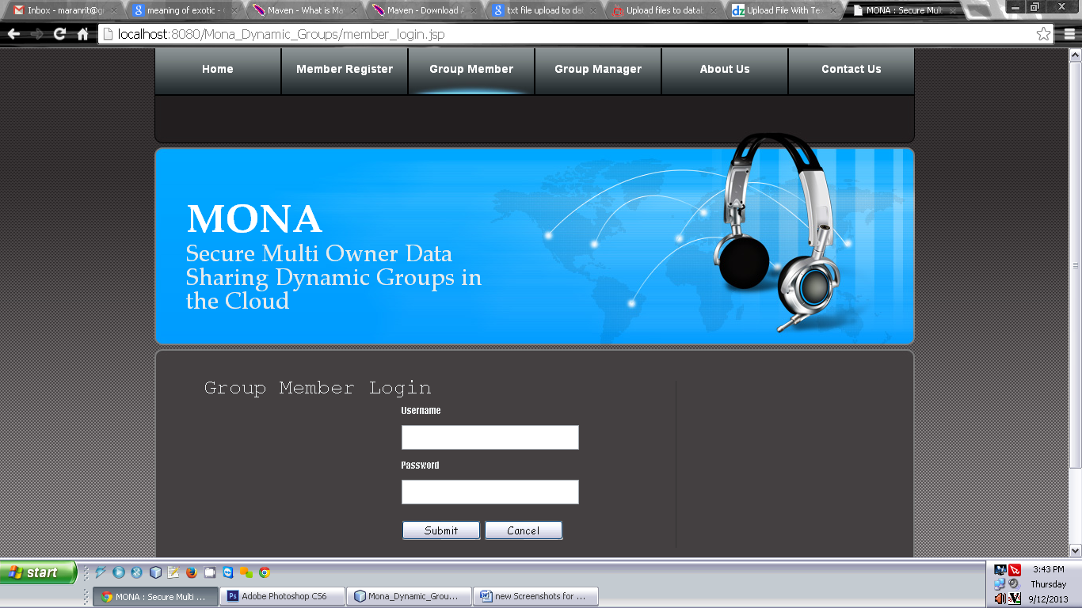

Note that, the group membership is dynamically changed, due to the staff resignation and new employee participation in the company. The group member has the ownership of changing the files in the group. Whoever in the group can view the files which are uploaded in their group and also modify it. The group meme

4.4 File Security Module
1. Encrypting the data file.
2. File stored in the cloud can be deleted by either the group manager or the data owner.
(i.e. the member who uploaded the file into the server).

4.5. Group Signature Module
A group signature scheme allows any member of the group to sign messages while keeping the identity secret from verifiers. Besides, the designated group manager can reveal the identity of the signature’s originator when a dispute occurs, which is denoted as traceability.

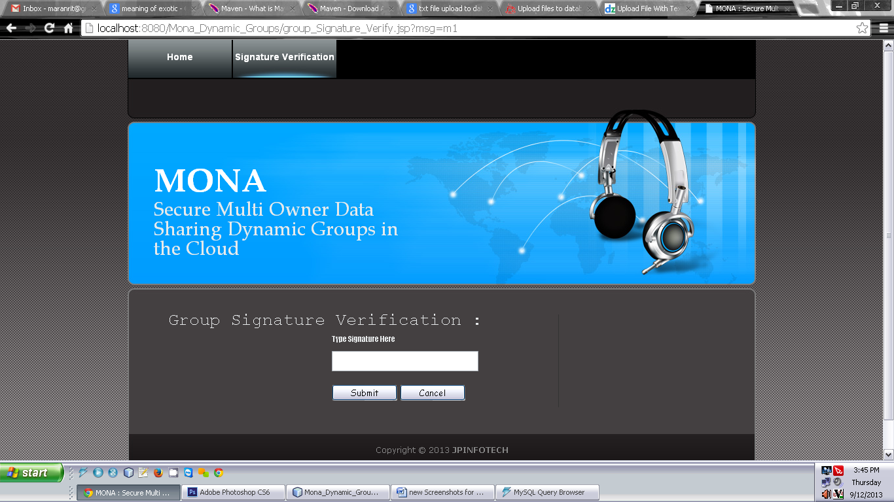

4.6 . User Revocation Module
User revocation is performed by the group manager via a public available revocation list (RL), based on which group members can encrypt their data files and ensure the confidentiality against the revoked users.

- CONCLUSION
Mona a secure data sharing scheme for dynamic groups in an untrusted cloud have been designed. In Mona, a user is able to share data with others in the group without revealing identity privacy to the cloud. Additionally, Mona supports efficient user revocation and new user joining. More specially, efficient user revocation can be achieved through a public revocation list without updating the private keys of the remaining users, and new users can directly decrypt files stored in the cloud before their participation. Moreover, the storage overhead and the encryption computation cost are constant. Extensive analyses show that our proposed scheme satisfies the desired security requirements and guarantees efficiency as well.

REFERENCES
- M. Armbrust, A. Fox, R. Griffith, A.D. Joseph, R.H. Katz, A. Konwinski, G. Lee, D.A. Patterson, A. Rabkin, I. Stoica, and M. Zaharia, “A View of Cloud Computing,” Comm. ACM, vol. 53, no. 4, pp. 50-58, Apr. 2010.
- S. Kamara and K. Lauter, “Cryptographic Cloud Storage,” Proc. Int’l Conf. Financial Cryptography and Data Security (FC), pp. 136-149, Jan. 2010.
- S. Yu, C. Wang, K. Ren, and W. Lou, “Achieving Secure, Scalable, and Fine-Grained Data Access Control in Cloud Computing,” Proc. IEEE INFOCOM, pp. 534-542, 2010.
- M. Kallahalla, E. Riedel, R. Swaminathan, Q. Wang, and K. Fu, “Plutus: Scalable Secure File Sharing on Untrusted Storage,” Proc. USENIX Conf. File and Storage Technologies, pp. 29-42, 2003.
- E. Goh, H. Shacham, N. Modadugu, and D. Boneh, “Sirius: Securing Remote Untrusted Storage,” Proc. Network and Distributed Systems Security Symp. (NDSS), pp. 131-145, 2003.
- G. Ateniese, K. Fu, M. Green, and S. Hohenberger, “Improved Proxy Re-Encryption Schemes with Applications to Secure Distributed Storage,” Proc. Network and Distributed Systems Security Symp. (NDSS), pp. 29-43, 2005.
- R. Lu, X. Lin, X. Liang, and X. Shen, “Secure Provenance: The Essential of Bread and Butter of Data Forensics in Cloud Computing,” Proc. ACM Symp. Information, Computer and Comm. Security, pp. 282-292, 2010.
- B. Waters, “Ciphertext-Policy Attribute-Based Encryption: An Expressive, Efficient, and Provably Secure Realization,” Proc. Int’l Conf. Practice and Theory in Public Key Cryptography Conf. Public Key Cryptography, http://eprint.iacr.org/2008/290.pdf, 2008.
- V. Goyal, O. Pandey, A. Sahai, and B. Waters, “Attribute-Based Encryption for Fine-Grained Access Control of Encrypted Data,” Proc. ACM Conf. Computer and Comm. Security (CCS), pp. 89-98, 2006.
- D. Naor, M. Naor, and J.B. Lotspiech, “Revocation and Tracing Schemes for Stateless Receivers,” Proc. Ann. Int’l Cryptology Conf. Advances in Cryptology (CRYPTO), pp. 41-62, 2001.
- D. Boneh and M. Franklin, “Identity-Based Encryption from the Weil Pairing,” Proc. Int’l Cryptology Conf. Advances in Cryptology (CRYPTO), pp. 213-229, 2001.
- D. Boneh, X. Boyen, and H. Shacham, “Short Group Signature,” Proc. Int’l Cryptology Conf. Advances in Cryptology (CRYPTO), pp. 41-55, 2004.
- D. Boneh, X. Boyen, and E. Goh, “Hierarchical Identity Based Encryption with Constant Size Ciphertext,” Proc. Ann. Int’l Conf. Theory and Applications of Cryptographic Techniques (EUROCRYPT), pp. 440-456, 2005.
- C. Delerablee, P. Paillier, and D. Pointcheval, “Fully Collusion Secure Dynamic Broadcast Encryption with Constant-Size Ciphertexts or Decryption Keys,” Proc. First Int’l Conf. Pairing-Based Cryptography, pp. 39-59, 2007.
- D. Chaum and E. van Heyst, “Group Signatures,” Proc. Int’l Conf. Theory and Applications of Cryptographic Techniques (EUROCRYPT), pp. 257-265, 1991.
- A. Fiat and M. Naor, “Broadcast Encryption,” Proc. Int’l Cryptology Conf. Advances in Cryptology (CRYPTO), pp. 480-491, 1993.
- B. Wang, B. Li, and H. Li, “Knox: Privacy-Preserving Auditing for Shared Data with Large Groups in the Cloud,” Proc. 10th Int’l Conf. Applied Cryptography and Network Security, pp. 507-525, 2012.
- C. Wang, Q. Wang, K. Ren, and W. Lou, “Privacy-Preserving Public Auditing for Data Storage Security in Cloud Computing,” Proc. IEEE INFOCOM, pp. 525-533, 2010.
- B. Sheng and Q. Li, “Verifiable Privacy-Preserving Range Query in Two-Tiered Sensor Networks,” Proc. IEEE INFOCOM, pp. 46-50, 2008.
- D. Boneh, B. Lynn, and H. Shacham, “Short Signature from the Weil Pairing,” Proc. Int’l Conf. Theory and Application of Cryptology and Information Security: Advances in Cryptology, pp. 514-532, 2001.
- D. Pointcheval and J. Stern, “Security Arguments for Digital Signatures and Blind Signatures,” J. Cryptology, vol. 13, no. 3, pp. 361-396, 2000.
- The GNU Multiple Precision Arithmetic Library (GMP), http://gmplib.org/, 2013.
- Multiprecision Integer and Rational Arithmetic C/C++ Library (MIRACL), http://certivox.com/, 2013.
- The Pairing-Based Cryptography Library (PBC), http://crypto.stanford.edu/pbc/howto.html, 2013

