**A modern technique for depreciation of ripple current using power electronic devices in renewable energy sources**

Dr.Khajamoinuddin1 Mr.H.kishan2

1,2EEE Depatment,SreeDattha Institute of Engineering & Science

***Abstract:*** In this proposed technique in which reduction in ripple current can be achieved without auxiliary switches. Here We considered current ripple which has twice frequency component is generated in the dc portion when suitable PWM inverter is used for grid purpose since ripple current shortens life span of electrolytic capacitors, batteries and fuel calls. The circuit realizes dc active filter without auxiliary switches due to buffer capacitor is connected to center tap of isolation transformer. We observed that results are verified with Matlab /Simulink.

**I. INTRODUCTION**

Typical systems include fuel cell systems, battery powered systems and even some photovoltaic systems. Numerous applications incorporates systems like emergency power back-up (UPS), de-centralized combined heat and power systems ,traction applications such as designed hybrid electrical vehicle systems , trucks and special made applications such as low emission power generation for truck and also ship containers and remote power generation for light towers, camper vans, boats, buoys etc**.**. Common to all of these applications is that cost of initial investment is high due to high cost of fuel cells, batteries or solar cells. Low conversion efficiency in the power electronic converter will significantly increase the required investment since more/larger cells will be needed.

In order to reduce the current ripple in the fuel cell, some approaches use high-speed current control. This method incorporates a current-loop control within the existing dc–dc converter voltage loop. However, a large capacitor or reactor is required as an energy buffer. Other approaches have been proposed that do not require the use of large-sized electrolytic capacitors, The dc active filter consists of a small capacitor as an energy buffer, a reactor to reduce the switching ripple, and a dc chopper. The dc chopper injects the ripple current to avoid a power ripple. The capacitance can be lower, because the terminal voltage of the capacitor can be varied over a wide range. However, the number of the switching devices is increased, requiring a high-cost dc chopper and resulting in a large volume device.

A large number of alternative converter topologies and implementations have been proposed, typically achieving high conversion efficiency at the medium to high input voltage range and at medium power levels. Best designs achieve peak efficiencies up to 96% .At maximum output power and minimum input voltage, however, efficiency typically drops significantly to 90 % or below. In fuel cell applications (and many others), peak power is reached at minimum input voltage, and available system peak power is directly affected by the decreased efficiency of the power converter. Thus, power source needs to be oversized in order to compensate for the reduced efficiency of the power converter. Furthermore, thermal design of the power converter itself needs to be dimensioned for this high peak power dissipation further increasing size and cost .

**II. PROPOSED SYSTEM CONFIGURATION**

Fig. 1 shows a conventional circuit which consists of a first stage inverter for the medium frequency link, a transformer, a diode rectifier, and a grid interconnection inverter. When the interconnection current and simultaneously power grid voltage seem to be sinusoidal waveforms, then the instantaneous power p of the grid interconnection is obtained by the equation (1) at unity power factor.



=VI…………….. (1)



Where I and V are treated as rms values of interconnection current and grid voltage the proposed circuit. In order to suppress the ripple current of the fuel cell, all the current ripples are provided by the energy buffer capacitor. Therefore, the capacitor current command *i∗* com is obtained by calculating the power ripple.

The capacitor current *i*com in the active buffer is controlled by a proportional–integral (PI) regulator to agree with the capacitor current command, and the dc active filter voltage command *v∗* com is output by the PI regulator. In order to obtain the maximum terminal voltage of the transformer, the differential-mode voltage command *v∗* dif is set to the maximum value. It should be noted that the maximum value of the voltage command is “1” when the peak value of the triangle carrier is “1.” The feature of the proposed circuit control is that the dc active filter voltage command *v∗* com is added to the differential voltage command *v∗* dif as the common-mode voltage. The output voltage commands *v∗*

1 and *v∗* 2 for each leg in the first-stage inverter power electronic converter.

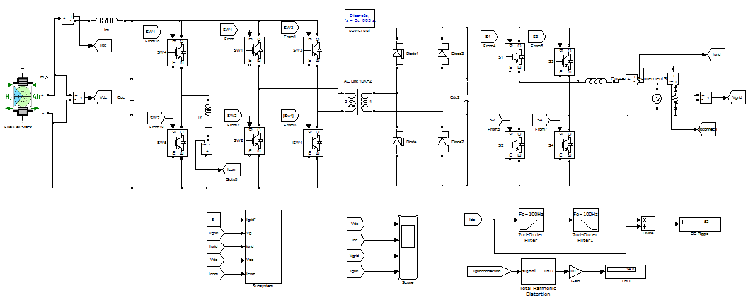

SIMULINK DIAGRAM

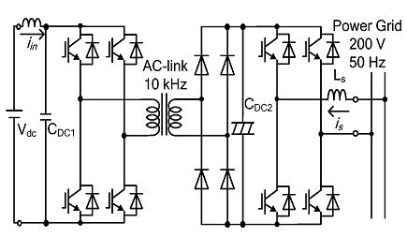

Fig. 1. Conventional circuit.

Fig. 2 depicts the another conventional circuit that employs dc active filter, along with dc chopper and buffer capacitor Cf where it role is to absorb the ripple power. But demerit of this model is increasing switching elements.

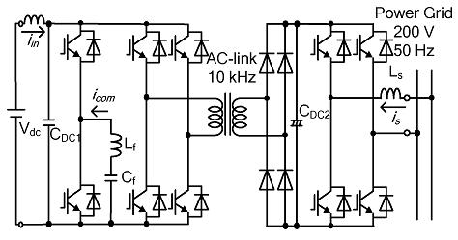

Fig. 2. Conventional circuit with dc active filter.

Now energy buffer capacitor role is to connect to center tap of medium frequency transformer.

**III. CONTROL STRATEGY**

The first-stage inverter in our proposed model has roles to perform one is dc/dc converter and other as dc active filter.

**A. Switching Pattern Generation Method**

Fig. 4. depicts the 2 switching modes of the first stage inverter in our proposed circuit. As discussed the differential mode, the terminal voltage of the transformer is directly controlled, as shown in Fig 4(a) and (b) Similarly the common mode, the center tap voltage is controlled, as shown in Fig. 4(c) and (d). Like wise If we the differential mode is selected, the power immediately transfers to the secondary side .Now the capacitor voltage is definitely greater than half of the DC voltage, and the buffer capacitor gets charged.

When the capacitor voltage is less than half of the dc voltage, the buffer capacitor gets discharged and inverter outputs gets zero voltage vectors (00 and 11 are two) in common-mode operation. Likewise zero voltage vectors are selected, the lineto-line voltage of the transformer is zero.

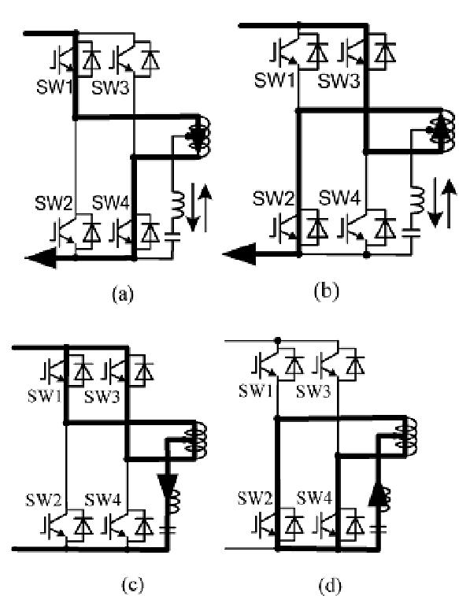

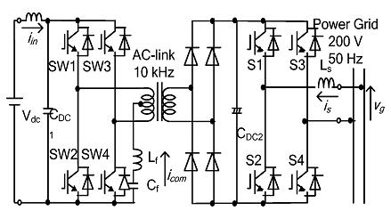

|  |  |  |
| --- | --- | --- |
|  |  |  |

Fig. 3 shows our proposed circuit, that combines the first stage inverter and dc active filter function

Fig. 4 Switching Pattern Generation

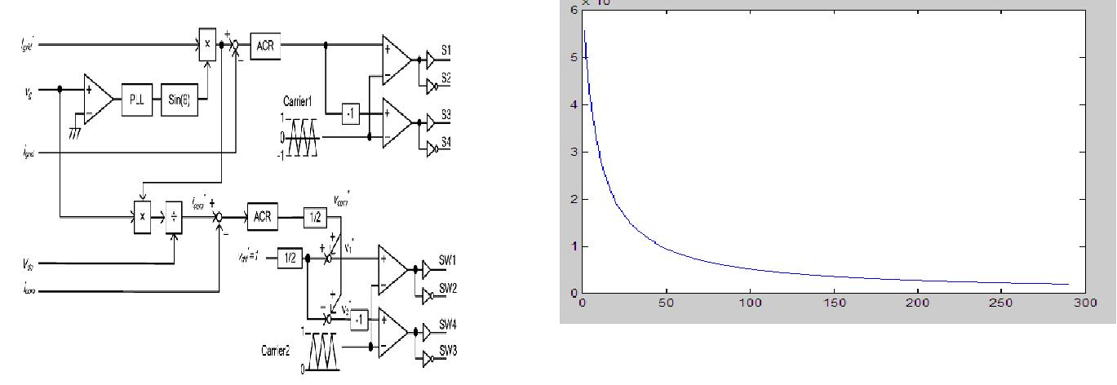

Fig. 5a Control block diagram of the proposed circuit.

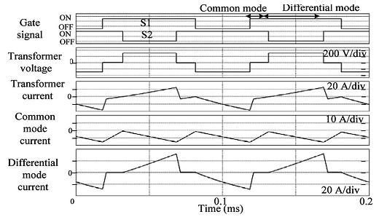

Fig. 5b Current and voltage waveforms for differential-mode and common mode operations

**B.** **Design of the Buffer Capacitor for dc Active Filter Operation**

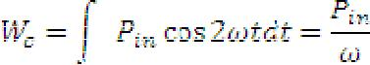

…… (3)



)……. (4)



**IV.SIMULATION RESULTS**

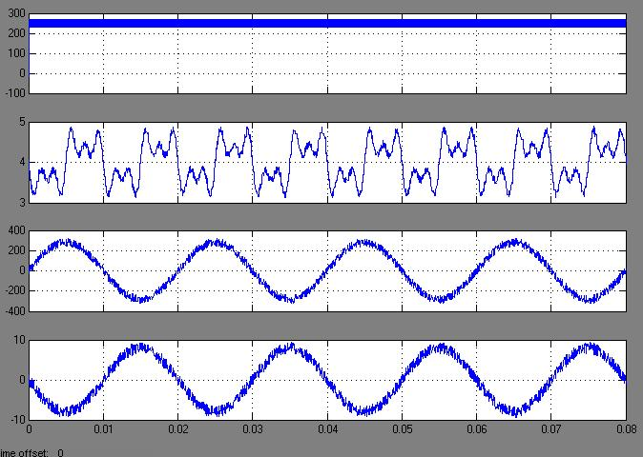

Fig.. Operation waveforms of the proposed circuit



Fig.Operation waveforms of the conventional circuit with a large electrolytic capacitor Cdc2=2200µF.

**V CONCLUSION**

A novel single-phase isolated converter had designed with careful nature for interconnection grid purpose applications. We observed that ripple current in a dc power supply, such as a fuel cell, battery, or photovoltaic cell, can be reduced by the appropriate operation of a dc active filter.

VI REFERENCES

[1] S. Sumiyoshi, H. Omuri, and Y. Nishida, “Power conditioner consisting of utility interactive inverter and soft-switching DC–DC converter for fuel-cell cogeneration system,” in *Proc. IEEE PCC 2007*, Nagoya, Japan,

pp. 455–462.

[2] R. Nojima, I. Takano, and Y. Sawada, “Transient performance of a newtype hybrid electric power distributed system with fuel cell and SMES,” in *Proc. IEEE IECON 2001*, pp. 1303–1308.

[3] H. Cha, J. Choi, and B. Han, “A new three-phase interleaved isolated boost converter with active clamp for fuel cells,” in *Proc. IEEE PESC* *2008*, pp. 1271–1276.

[4] L. Danwei and L. Hui, “A three-port three-phase DC–DC converter for hybrid low voltage fuel cell and ultracapacitor,” in *Proc. IEEE IECON* *2006*, pp. 2258–2563.

[5] P. T. Krein and R. Balog, “Low cost inverter suitable for medium-power fuel cell sources,” in *Proc. IEEE PESC 2002*, pp. 321–326.

[6] B. Bouneb, D. M. Grant, A. Cruden, and J. R.McDonald, “Grid connected inverter suitable for economic residential fuel cell operation,” in *Proc. IEEE EPE 2005*, p. 10.