A Novel Controlling Of Micro-Grid And Islanding Operations Of Distributed Generation Systems With Power Electronic Devices

Mr. J.Ranga¹, Mr.A.Anjaneyulu²
^{1,2}Department of EEE, SreeDattha Institute of Engineering and Science,Hyderabad.

Abstract: The main aim of this paper is to propose a concept of micro-grid under smart distribution environment conditions with distributed generation resources like solar, wind and fuel etc. In present scenario, the importance of distribution sources is very high for maintaining the system reliability and also for providing backup generation under islanding condition and also as well as in grid-connected conditions. For meeting these limitations this paper proposes a new control structure called power-voltage- current controller. Basically, the main aim of these controller is to provide flexible and robust distributed generation operation control characteristics such as (a) control of PQ and PV in grid connected mode. (b) To provide regulated power under micro-grid. (c) For providing smooth transients between islanding and grid-connected modes and (4) finally, this controller also concentrates on reduction of distortions/harmonics in proposed system which is caused by heavily non-linear loading conditions. The performance of this system is verified by using Matlab/simulink tool box.

- INTRODUCTION
Generally, in power grids the flexible operation of distributed generation is a major objective. The greater part of DG units are interfaced to grid/load by means of power hardware converters. Under the brilliant grid environment, distributed generation units ought to be incorporated into the network operational control structure, where they can be utilized to improve system dependability by giving reinforcement generation in separated mode, and to give auxiliary administrations in the grid-connected mode [1]. These operational control activities are powerful in nature as they rely on upon the heap/generation profile, request side administration control, and general system advancement controllers.
To accomplish this vision, the DG interface ought to offer high adaptability and strength in meeting an extensive variety of control capacities, for example, consistent exchange between islanding and grid connected modes; consistent exchange between active/reactive power (PQ) and dynamic power/voltage (PV) methods of operation in the grid connected mode; vigor against islanding recognition delays; offering negligible control-capacity exchanging amid mode move; and keeping up a various leveled control structure [2]. A few control framework upgrades have been made to the progressive control structure to improve the control execution of DG units either in grid-connected or segregated miniaturized scale grid systems.

- SYSTEM CONFIGURATION
Figure 1 shows the basic schematic structure for proposed micro-grid system. This system generally represents, a low voltage distribution systems, different types of load and also a different number of distribution generation units can be chosen for connecting to main feeder. In this system the distribution systems which is connected to main feeder are work in parallel with main grid or in islanding condition to serve sensitive loads which is connected to main feeder system. When the grid system is connected to distribution generation system at point of common coupling, the voltage and frequency levels are main criteria. Suppose, in the case of week grid system, there is a chance to occurrence of voltage sags and disturbances in the system. For compensating these problems the distribution units may helpful. In this way, both PQ and PV operational modes [3] can be embraced in the grid-connected mode.
Fig 1: Basic schematic structure for proposed micro-grid system

The state space representation for the distributed generation system under both grid and islanding conditions can be formulated [4] as,
$$\begin{aligned}v_{\text{invabc}}=L\frac{{\text{di}}_{\text{Labc}}}{\text{dt}}+v_{\text{oabc}} \\ i_{\text{Labc}}=i_{\text{oabc}}+i_{\text{cabc}}=i_{\text{oabc}}+C\frac{{\text{dv}}_{\text{oabc}}}{\text{dt}}\end{aligned}$$
- DISTRIBUTION GENERATION SYSTEMS

- SOLAR SYSTEM:
In electrical phenomenon photovoltaic network, the cell is that the essential part. PV exhibit is nothing however sunlight based cells region unit associated non-concurrent or parallel for increasing required current, voltage and high power. Each cell is practically identical to a diode with an intersection designed by semiconductor material. It delivers the streams once lightweight consumed at the intersection, by the electrical marvel sway. It are frequently seen that a most electric outlet exists on each yield power diagram. The Figure 3 shows the (I-V) and (P-V) characteristics of the PV exhibit [5] at entirely unexpected star intensities.
$$\begin{aligned}I=I_{\text{ph}}−I_{d}−I_{\text{sh}} \\ I=I_{\text{ph}}−I_{o}[\text{exp}({{\text{qV}}_{d}}/{\text{nKT}})]−({V_{d}}/{R_{s}})\end{aligned}$$
Figure 2: Equivalent circuit of PV Module
Power output of solar cell is P = V * I
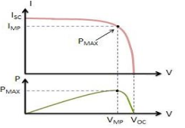
Figure 3: Output characteristics of PV Array
- DIESEL GENERATOR SET:
In remote area locations, the diesel energy generation systems are more successful parts for distributing power. This sort of dissemination energy stockpiling systems are stacked with unbalanced burdens and non-direct loads. Because of this heap variety causes the varieties in power system parameters [6]. Figure 4 demonstrates the schematic outline for diesel energy system serves the diverse loads, for example, straight loads, non-direct loads and so on.
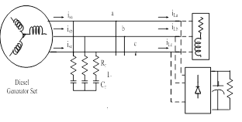
Figure 4: Structure for Diesel Energy Generation System

- CONTROL STRUCTURE FOR PROPOSED MICRO-GRID SYSTEM
Figure 5 shows the control structure for proposed micro-grid system which is used for compensating the external disturbances caused by the system. And the internal disturbances which is caused due to switching control functions between grid and islanding modes is also eliminated by using this hierarchical control system, and to achieve flexible and robust operation of distribution generation units [7]-[8].

Figure 5: Control Structure for micro-grid system
Figure 6 shows the proposed internal model controller based voltage control structure. This system is designed by choosing the input and output relation between voltage and current as shown in below transfer function. In this the variable ‘m’ is the nominal model parameter. And ‘Ʈ’ is the time constant for tracking bandwidth of the system [10] [11]. The sensitivity transfer function for the proposed system, is represented as $\frac{v_{o}}{i_{0}}$and shown as follows:
$$\frac{v_{o}}{i_{o}}=\frac{L_{s}}{K_{c}Q_{d}(s)+{\text{LCs}}^{2}+(R_{d}C+K_{c}C)s+1}$$
Figure 6: Hierarchical Controller Design
The embraced hierarchical configuration approach gives flexible operation of the DG unit in grid-associated mode. To minimize the control exchanging activities between grid-associated and secluded modes, a solitary dynamic power control structure is utilized as a part of both modes. The proposed dynamic power controller, appeared in figure 4, [12] comprises of a moderate integrator, which produces recurrence deviations as per the power-recurrence attributes introduced in condition [13].
$$Δw=m(P^{}−P)$$

- EXPERIMENTAL SETUP AND RESULTS
The performance of the proposed micro grid system shown in figure 1 is evaluated by using time domain based Matlab/simulink tools. In this the micro grid system consists of two distribution generating units such as solar and diesel systems. These systems either can work in parallel with main grid or in islanding conditions.
Case 1: Grid Connected Mode
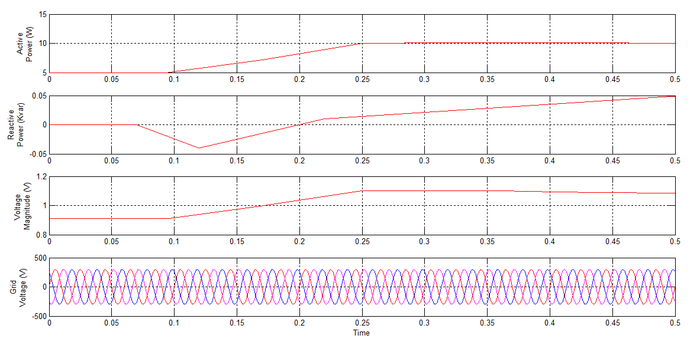
Figure 7: Simulation results under grid connected mode (a) Active Power, (b) Reactive Power, (c) Magnitude of Voltage and (d) three phase grid voltages.
Figure 7 shows the simulation result for proposed system under grid conncted secnario. Graph 7(a) and 7(b) shows the resluts for active and reactive power. Graph 7(c) shows changes occurance in output voltage magnitude in order to maintain unity power factor irrespective of changes in active power. The instataneous three phase output voltage at point of common coupling is shown in figure 7(d).

Case 2: Grid Connected Mode with Sag Condition
Figure 8 shows the simulation result for grid connected system under variations in load voltage such as sag condition. In this the grid voltage faces a 10% sag from 0.2s to 0.35s due to effect of fault presence in main utility grid system. And this effect can be completely compensated with the help of distribution generation system as shown in figure 8(b).
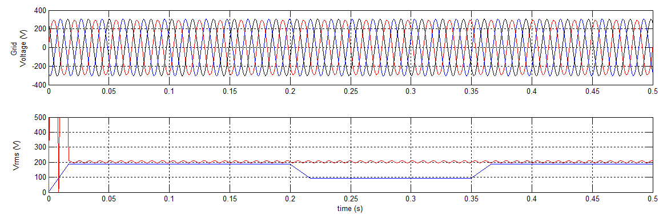

Figure 8: Simulation result for grid connected system under variations in voltage.

Case 3: Grid Connected Mode with Disturbance Condition
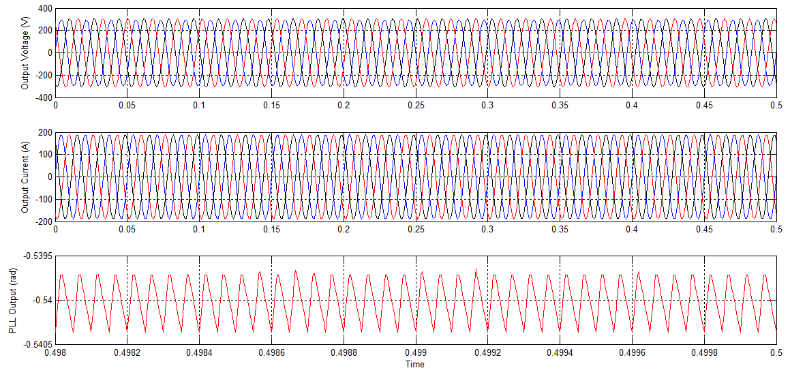
Figure 9: Simulation result for grid connected system with disturbances caused by sudden changes of Load
Figure 9 shows the simulation results for grid connected system under sudden variations in load. Graph 9(a) shows the simulation result for output voltage and graph 9(b) shows the simulation result for output current and graph 9(c) is the simulation result for PLL output for output voltage. In this case the system is effect with sudden changes of load at t=0.25sec. From this time the system output voltage and current is effected by disturbance/harmonics.

Case 4: Islanded Mode
Initially, the micro grid system is connected to grid system and also both distribution generation units are in working condition. In this case the performance of the system under islanding mode is proposed. The utility grid is disconnected from the micro grid system with the help of circuit breaker switch. Distributed Generation units works based on the P-V-I control structure, which is applied for both grid and islanded conditions. Figure 10 shows the simulation results for proposed system under islanding condition.

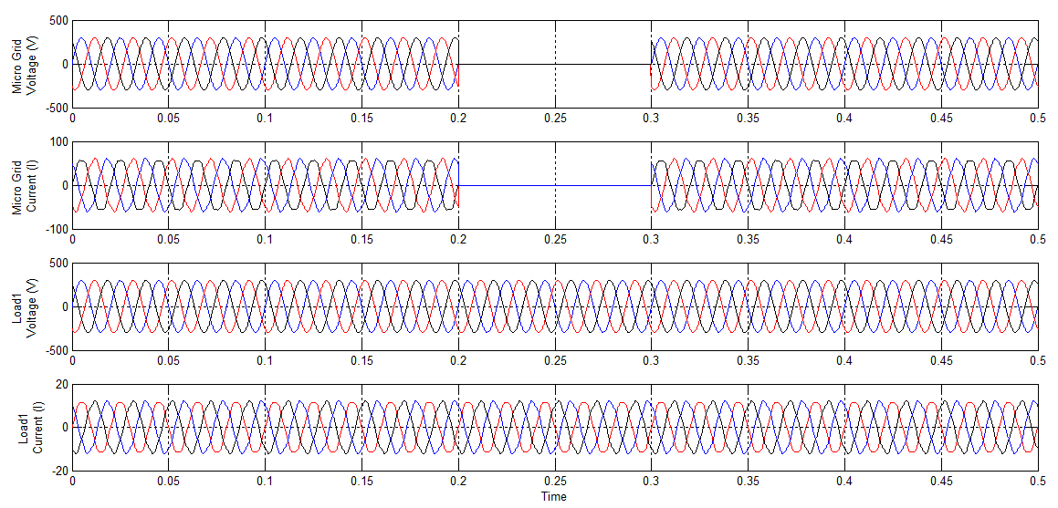
Figure 10: Simulation Results for Islanding system (a) micro-grid voltage, (b) Micro-grid current, (c) Load voltage and (d) load current

- CONCLUSION
In this paper, an effective distribution and flexible operation in micro grid proposal under the environment of smart distribution system is proposed. In this proposed system the distribution units is considered as photovoltaic and diesel generator system because of its flexible operation, high reliability and also low maintaince cost. And also the P-V-I control structure which is proposed in this paper has simple, reliable and also linear control strategy that provides flexible operation in both grid and as well as in islanding conditions. The performance of this control strategy is observed by its suitable PQ and PV characteristics. And from the simulation results, we concluded that the proposed control structure in micro-grid system enhances the flexibility operation in both grid and islanding modes under dynamic conditions of future smart distribution systems.

REFERENCES
- Smart Grid: An Introduction U.S. Department of Energy, 2009.
- E. M. Lightner and S. E. Widergren, “An orderly transition to a transformed electricity systems,” IEEE Trans. Smart Grid, vol. 1, no. 1, pp. 3–10, Jun. 2010.
- K. Moslehi and R. Kumar, “A reliability perspective of smart grid,” IEEE Trans. Smart Grid, vol. 1, no. 1, pp. 57–64, Jun. 2010.
- G. T. Heydt, “The next generation of power distribution systems,” IEEE Trans. Smart Grid, vol. 1, no. 3, pp. 225–235, Nov. 2010.
- A. Timbus, M. Liserre, R. Teodorescu, P. Rodriquez, and F. Blaabjerg, “Evaluation of current controllers for distributed power generation systems,” IEEE Trans. Power Electron., vol. 24, no. 3, pp. 654–664, Mar. 2009.
- J.M.Guerrero, J. C.Vasquez, J.Matas, K.Vicuna, and M. Castilla, “Hierarchical control of droop-controlled ac and dc microgrids—A general approach towards standardization,” IEEE Trans. Ind. Electron., to be published.
- M. Liserre, R. Teodorescu, and F. Blaabjerg, “Multiple harmonics control for three-phase grid converter systems with the use of PI-RES current controller in a rotating frame,” IEEE Trans. Power Electron., vol. 21, no. 3, pp. 836–841, May 2006.
- Y. A.-R. I. Mohamed, “Mitigation of dynamic, unbalanced and harmonic voltage disturbances using grid-connected inverters with LCL filter,” IEEE Trans. Ind. Electron., vol. 58, no. 9, pp. 3914–3924, Sep. 2011.
- S. Ahn, “Power-sharing method of multiple distributed generators considering modes and configurations of a microgrid,” IEEE Trans. Power Del., vol. 25, no. 3, pp. 2007–2016, Jul. 2010.
- Twinning and D. G. Holmes, “Grid current regulation of a three phase voltage source inverter with an LCL input filter,” IEEE Trans. Power Electron., vol. 18, no. 3, pp. 888–895, May 2003.
- D. De and V. Ramanarayanan, “Decentralized parallel operation of inverters sharing unbalanced and nonlinear loads,” IEEE Trans. Power Electron., vol. 25, no. 12, pp. 3015–3022, Dec. 2010.
- H. Kim, T. Yu, and S. Choi, “Indirect current control algorithm for utility interactive inverters in distributed generation systems,” IEEE Trans. Power Electron., vol. 23, no. 3, pp. 1342–1347, May 2008.
- Z. Yao, L. Xiao, and Y. Yan, “Seamless transfer of single-phase grid interactive inverters between grid connected and stand-alone modes,” IEEE Trans. Power Electron., vol. 25, no. 6, pp. 1597–1603, Jun. 2010.

