A Novel Video Authentication System Using Robust Embedding Algorithm

¹Dr sandeipan p narote, ²bharat kumar, ³g srikanth
^{1,2,3}Department of Electronics and Communication Engineering.SreeDattha Institute of Engineering & Science

Abstract: Protecting of digital information is a challenging task in multimedia world. We must need to provide an authentication for a digital content that should be sent over the communication channel in such a way that the content should not be copied by unauthorized people. To resolve this issue, we have implemented a possible solution that is visible watermarking for Copyright or ownership applications. Here, a novel video authentication system has been implemented using robust embedding algorithm also calculated the quality metrics such as structural similarity index (SSIM), and covariance (CV) for secure concern. Simulation analysis has shown that the proposed embedding algorithm also performed as an excellent reconstructor at the receiver end.
Keywords: Digital Video, Watermarking, FFT, DCT, DWT, Compound Mapping, SSIM, CV, PSNR and MSE
- INTRODUCTION
The progress of PC innovations and the proliferation of the Internet have made propagation and appropriation of computerized information less demanding than at any other time. Copyright security of scholarly properties has, hence, turn into a critical topic. One path for copyright security is computerized watermarking [1]–[7], which means installing of certain speciﬁc information about the copyright holder (organization logos, proprietorship depictions, and so on.) into the media to be ensured. Barring the conspicuous instance of unmistakable watermarks, we can group the watermarks as FRAGILE or ROBUST. The delicate watermark is utilized for recognizing even the littlest alteration of a picture, while the vigorous one is uncommonly intended to withstand an extensive variety of "assaults", which fundamentally are attempting to expel the watermark, yet without obliterating the picture/video. Noticeable watermarking is connected with the impression of the human eye to distinguish where the information has been installed on the picture. The hindrance of this strategy is that the watermarked picture does not resemble the first one but rather then again disheartens the assailant to assault the picture. A noticeable watermark is an obvious translucent picture which is overlaid on the essential picture. Maybe comprising of the logo or seal of the association which holds the rights to the essential picture, it allows the essential picture to be seen, yet at the same time checks it unmistakably as the property of the owning association. It is essential to overlay the watermark in a way which makes it hard to evacuate, if the objective of demonstrating property rights is to be accomplished. Imperceptible watermarking is the strategy that can conceal the information on the picture breaking down if undetectable to the human eye. The drawback is that is more powerless against assaults then again the picture is indistinguishable to the first one. Undetectable watermarks can be comprehensively arranged into two sorts, strong and delicate watermarks. Powerful watermarks are for the most part utilized for copyright security and proprietorship check since they are hearty to almost a wide range of picture handling operations. In correlation, delicate watermarks are for the most part connected to substance confirmation and uprightness authentication since they are totally delicate to any changes.
An undetectable watermark is an overlaid picture which can't be seen, however which can be recognized algorithmically. Diverse utilizations of this innovation call for two altogether different sorts of imperceptible watermarks:
- A watermark which is pulverized when the picture is controlled carefully in any capacity might be helpful in demonstrating legitimacy of a picture. On the off chance that the watermark is still in place, then the picture has not been "doctored." If the watermark has been devastated, then the picture has been messed with. Such an innovation may be essential, for instance, in conceding advanced pictures as proof in court.
- An undetectable watermark which is extremely impervious to pulverization under any picture control may be helpful in checking responsibility for picture associated with misappropriation. Advanced location of the watermark would demonstrate the wellspring of the picture.

- Characteristic of Watermarks:
- Imperceptibility:
The watermark must be undetectable with the human eye. It is important to take into record to the most extreme model HVS (Human Visual System). Give us a chance to take two extremely basic cases to stress its significance. Give us a chance to envision a picture in level of dark with an expansive uniform zone. On the off chance that one includes a little noise, this instantly will be found in this zone. It is fairly important to put the watermark in zones of solid slope (edges of shapes, emphatically finished zones...) where the eye is less touchy. Another case originates from the watermarking of the pictures hues. It is realized that the human eye is not delicate similarly to every one of the wavelengths. One can in this manner pretty much dissimulate information as indicated by the shading considered.
- Strength:
We could separate this heading in two sections: "the strength and the security". These two attributes are frequently confounded particularly on account of the watermarking. Normally, heartiness is utilized to characterize the resistance of the watermarking versus transformations of the watermarked picture. These transformations can be of geometrical sort (turn, zoom, cropping...). They can alter certain qualities of the picture (histogram of the hues, saturation...). They can likewise be every one of the sorts of frequential debasements of the picture (lossy compression, high pass channels or low pass channel, analogical->numérique->analogique entry, impression of the picture, etc....). These assaults are called "daze assaults", on the grounds that the pirate demonstrations without truly realizing what it does. He in this manner would like to wash the picture. The security portrays the path in which the watermarking will oppose "noxious" assaults. We can make parallels with the cryptanalyse. The pirate will try to wash the picture in a savvy way. He is sensible to know the algorithm and, as a rule, will look for the key which peruses the watermark. That regularly requires a careful analysis of the watermarking technique utilized.

- Many-Sided Quality:
By and by, most of the operations of the watermarking must have the capacity to be done continuously (particularly the discovery, for movies for instance). This suggests an extra requirement on the many-sided quality of the operations utilized for the watermarking and the identification. Limit The limit of a numerical arrangement of the watermarking shows the report/ratio: "various information" to (stored) dissimulate on "the span of the host archive (picture)". On account of watermarking, limit regularly restrains itself to 1 bit. Numerous algorithms dissimulate a few bits (for instance JAWS which transmits 8 bits a moment video). In a general way, more the limit is feeble, increasingly the strength and the subtlety is solid.

- Watermark Classification:
There are a few criteria how watermarks for pictures or video groupings can be characterized. Watermarking techniques can be ordered into spatial or frequency area by place of utilization. Spatial area watermarking is performed by changing estimations of pixel shading tests of a video outline while watermarks of frequency space techniques are connected to coefficients acquired as the aftereffect of a frequency transform of either an entire casing or single block-molded locales of a casing. Discrete Fourier Transform and Discrete Wavelet Transform have a place among entire casing frequency transforms. The delegate of the block frequency transform is Discrete Cosine Transform. Order into these gatherings is as per the way how the transforms are generally utilized as a part of practice. Video arrangements compacted by advanced techniques offer another kind of area, movement vectors. Watermarking in this space marginally modifies length and bearing of movement vectors. Encourage, watermarks for video arrangements can be ordered by the scope of use e.g. shrouded information conveyed by a watermark can be spread general casings of the video arrangement, then the entire grouping is important to recover that information, or every casing contains watermark with a similar information, then just a solitary edge ought to be sufficient. In one casing, one single component of the watermark can be implanted into one pixel, into a block of pixels or even into the entire edge. Picture watermarking algorithms can be ordered into two classifications: spatial area techniques (spatial watermarks) and frequency space techniques (otherworldly watermarks). The spatial area specifically changes the powers or shading estimations of some chose pixels while the frequency area alters the estimations of a few transformed coefficients (discrete cosine transform "DCT", discrete wavelet transforms "DWT").

- RELATED WORK
Advanced watermarking techniques for pictures are generally classified into two sorts: imperceptible and obvious. The ﬁrst sort expects to install copyright information vaguely into host media to such an extent that in instances of copyright encroachments, the shrouded information can be recovered to distinguish the responsibility for secured have. It is imperative for the watermarked picture to be impervious to normal picture operations to guarantee that the concealed information is still retrievable after such alterations. Strategies for the second sort, then again, yield unmistakable watermarks which are for the most part plainly noticeable after regular picture operations are connected. Furthermore, noticeable watermarks pass on possession information straightforwardly on the media and can stop endeavors of copyright infringement. Installing of watermarks, either noticeable or imperceptible, debase the nature of the host media when all is said in done. A gathering of techniques, named reversible watermarking [8]–[19], allow genuine clients to evacuate the implanted watermark and restore the first substance as required. Notwithstanding, not all reversible watermarking techniques ensure lossless picture recuperation, which means that the recouped picture is indistinguishable to the first, pixel by pixel. Lossless recuperation is vital in numerous applications where genuine worries about picture quality emerge. A few illustrations incorporate crime scene investigation, medicinal picture analysis, historical craftsmanship imaging, or military applications. Contrasted and their imperceptible partners, there are moderately few notices of lossless obvious watermarking in the writing. A few lossless undetectable watermarking techniques have been proposed before. The most widely recognized approach is to pack a part of the first host and afterward install the compacted information together with the expected payload into the host [5], [13]–[15]. Another approach is to superimpose the spread-range signal of the payload on the host so that the signal is perceptible and removable [3]. A third approach is to control a gathering of pixels as a unit to insert a bit of information [16], [17]. Albeit one may utilize lossless imperceptible techniques to insert removable unmistakable watermarks [11], [18], the low installing limits of these techniques frustrate the likelihood of embedding expansive estimated obvious watermarks into host media. As to lossless obvious watermarking, the most well-known approach is to implant a monochrome watermark utilizing deterministic and reversible mappings of pixel qualities or DCT coefﬁcients in the watermark locale [6], [9], [19]. Another approach is to pivot sequential watermark pixels to implant an obvious watermark [19]. One preferred standpoint of these methodologies is that watermarks of arbitrary sizes can be inserted into any host picture. Notwithstanding, just twofold noticeable watermarks can be implanted utilizing these methodologies, which is too prohibitive since most organization logos are vivid. Another technique for lossless unmistakable watermarking is proposed by utilizing compound mappings which allow mapped qualities to be controllable The approach is non specific, prompting to the likelihood of implanting distinctive sorts of obvious watermarks into cover pictures. Two uses of the proposed technique are demonstrated; where we can implant misty monochrome watermarks and non-consistently translucent full-shading ones into shading pictures.
Next we would see the sorts of checking. Watermarking should be possible by
- Changing straightforwardly the estimations of the pixels, in the spatial space.
- Inserting the watermark in the frequency space, utilizing one of the outstanding transforms: FFT, DCT or DWT.
- Using fractals.
The most straightforward (least complex) approach to watermark a picture/video, is to change specifically the estimations of the pixels, in the spatial space. A more propelled approach to do it, is to embed the watermark in the frequency space, utilizing one of the notable transforms: FFT, DCT or DWT. Different techniques are conceivable also, such as utilizing fractals for instance. The watermark inserting should be possible consistently (or in some other observational way), which doesn't represent the HVS properties (this is called non-perceptual checking). On the other hand, the watermarking implanting can utilize some HVS models so as to improve the inserting. Contingent upon the HVS display utilized, the perceptual checking can be video free (fundamental HVS demonstrate) or ideally video subordinate (progressed HVS show).

- PROPOSED ALGORITHM
Here, we propose a generic one-to-one compound mapping for converting a set of numerical values,, such that the mapping and for all is reversible. Here, all the values of and are gray scale or color image pixel values, which are investigated for copy right protection applications. The compound mapping f is governed by a one-to-one function with one parameter in the following way:
(1)
Where is the inverse of
The compound inverse mapping will be obtained by eq.1 is given by
(2)
The proposed algorithm is described as follows:
Algorithm 1:
Input: Original video, watermark logo image
Output: Watermarked Video
Steps:
- First, select and read the original video from the current directory folder in MATALB
- Convert the video into number of frames i.e., number of frames per second
- Then convert the frames into number of images, from these set of images select the image and select a set of ‘P’ pixels where the logo is to be embedded, where P is watermarking area.
- Corresponding set of pixels P in are denoted by Q.
- For each pixel X with value p in P, corresponding pixel in Q is denoted as Z and corresponding pixel Y in L as l and follow the below steps.
(a). Apply an estimation technique to derive ‘a’ to be a value close to ‘b’ using the value of the neighboring pixels of X
(b). Set ‘p’ to be the value ‘l’
(c). Map ‘p’ to a new value.
(d). the value of Z is set to q.
- Now, repeat the same process for every image, i.e., the set of images obtained from the original video.
- Reconstruct the images into frames and then into video, which is a watermarked video in which the logo image has been embedded for copyright protection applications.
As an example, the purpose performed by Step:5 of the above algorithm for a pixel is illustrated by below figure 1 .Here the color of the center pixel is estimated by using west and north pixels As the pixels are unknown to the receiver and covered by the watermark the east and south pixels are not used. Following algorithm describes removal process for watermarked image.
Algorithm2:
Input: watermarked Video, watermark logo(L).
Output: recovered video ‘R’.
Steps:
- First, read the watermarked video and covert the video into number of frames
- Now, convert the frames into the number of images and select the image ‘W’ form the set of images .
- The watermar king area Qis selected in W as the are a selected inAlgorithm1.
- Value of each pixel in Risset, which his outside the region Q, to bee qualto the corre sponding pixelin W. For each pixelZ with valueq in Q, denote the corresponding pixelin the recover edimage Ras Xand the value of the corresponding pixel Yin Lasl, and conduct the following steps. (a)
- Obtain the same value by applying the same stimation technique used.
- b) Set btobe the valuel.
- c) Restorep from q by setting
- d) Set the valueof Xtobep
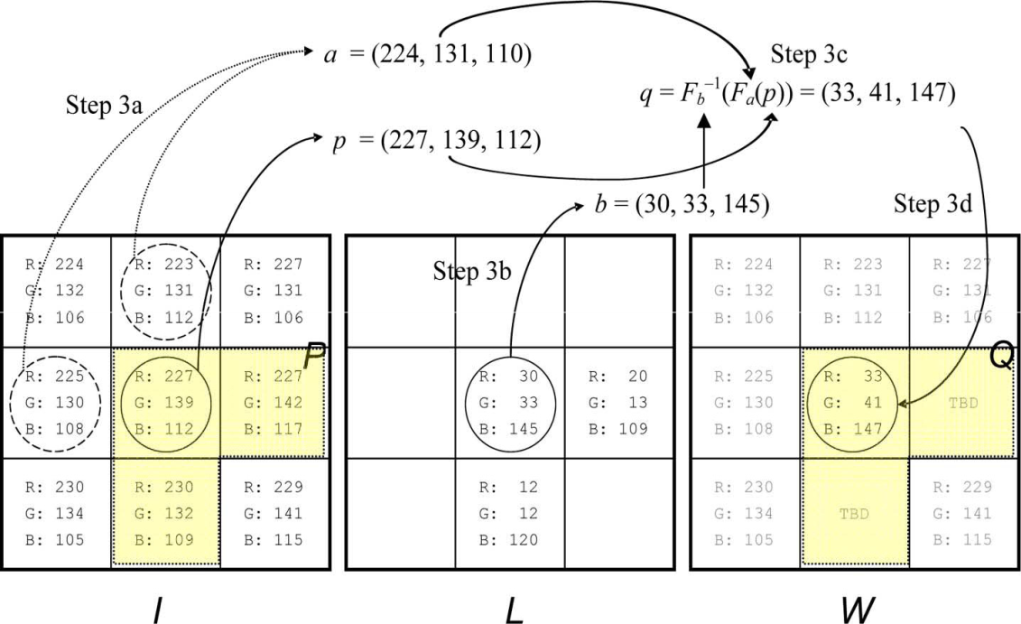
Figure1 Proposed Scheme

- SIMULATION RESULTS
All the experiments have been done in MATLAB environment. Various video contents have been used to test the proposed embedding algorithm for video authentication. We also considered few color images for visible image watermarking using graphical user interface design (GUID). It is a very simple and easy way to execute an application; it will provide a user friendly approach to obtain the required output by clicking the push buttons. Figure 2 shows that the GUI model of proposed visible image watermarking for copyright protection applications. We can observe that the 100% reconstruction has been achieved by the proposed extraction process which is called as lossless watermarking.
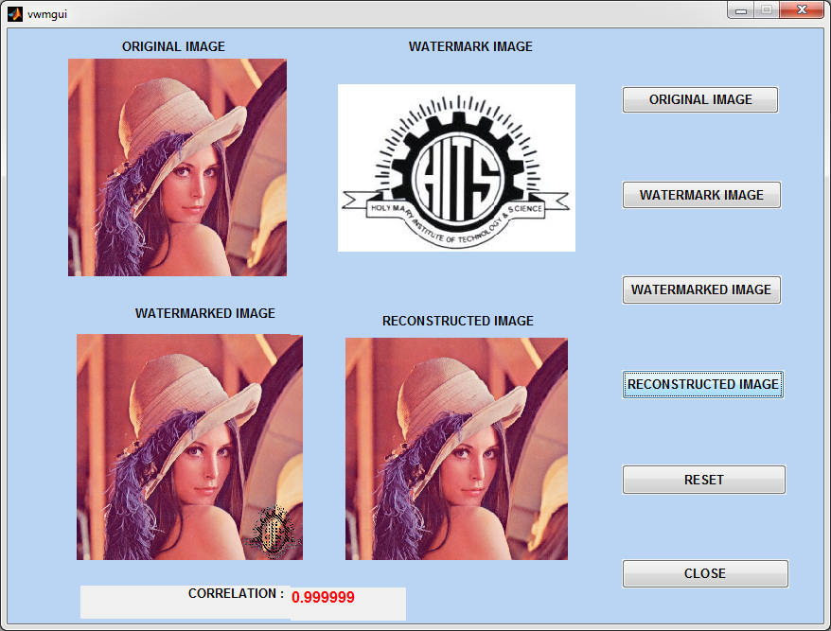
Figure2 GUI model1 of Proposed Visible Image Watermarking Algorithm
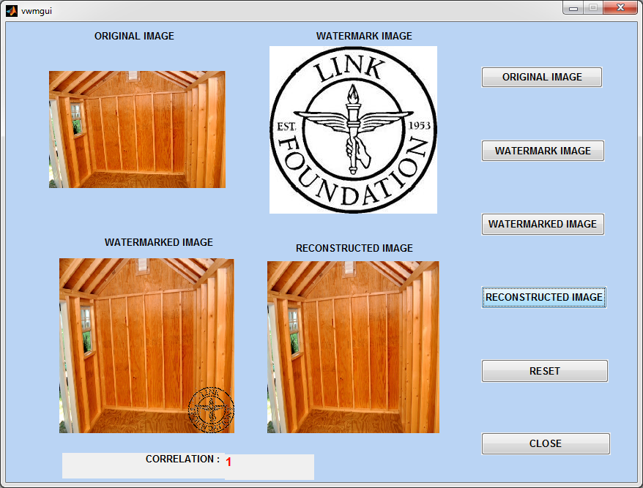

Figure3GUI model2 of proposed visible image watermarking algorithm
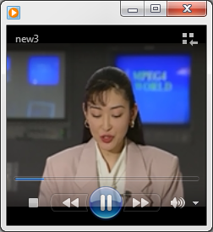


Figure4 (a) Original video frames

Figure4 (b) watermark logos
Proposed robust embedding algorithm for video authentication has been shown in figure 4 (a), (b), (c) and (d) respectively. fig4(a) shows that the original video frame, watermark logo has been shown in fig4(b). Watermarked frame, which has been obtained after applying proposed embedding algorithm has shown in fig4(c). Finally, reconstructed frame has been shown in fig4(d), which is same as original frame. Quality metrics comparison has shown in figure 5

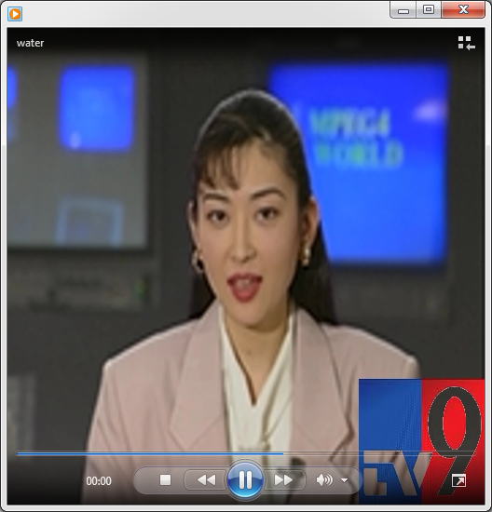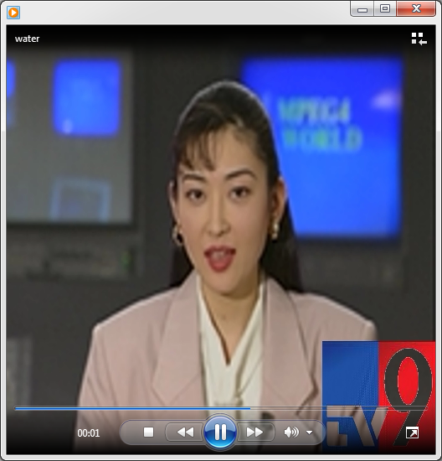
Figure4 (c) Watermarked frames
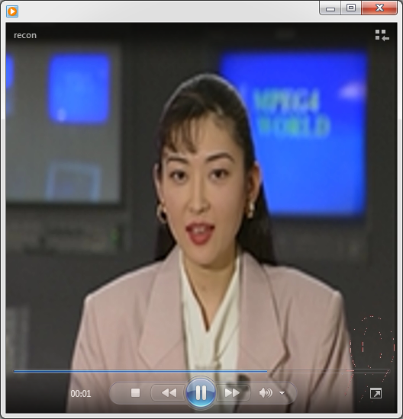
Figure 4 (d) Reconstructed frame
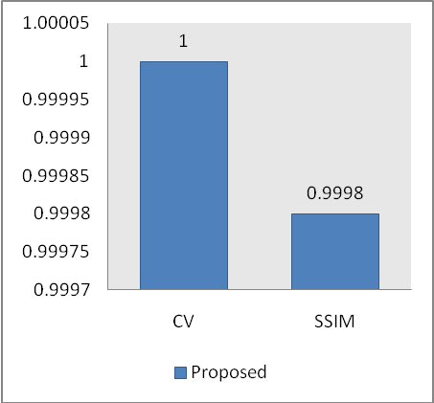
Figure5 Comparison of Quality Metrics

- CONCLUSIONS:
Novel video authentication using robust embedding and extraction algorithm has been proposed. Simulation analysis has been done with both images and videos for various applications. Quality metrics such as SSIM and CValso calculated for improving the performance of proposed algorithm in terms of secure concern. Finally, we have implemented an excellent watermark reconstructor also.

REFERENCES:
- F. A. P. Petitcolas, R. J. Anderson, and M. G. Kuhn, “Informationhiding—A survey,” Proc. IEEE, vol. 87, no. 7, pp. 1062–1078, Jul. 1999
- N. F. Johnson, Z. Duric, and S. Jajodia, Information Hiding. Steganography and Watermarking—Attacks and Countermeasures. Boston, MA: Kluwer, 2001.
- I. J. Cox, J. Kilian, F. T. Leighton, and T. Shamoon, “Secure spread spectrum watermarking for multimedia,” IEEE Trans. Image Process., vol. 6, no. 12, pp. 1673–1687, Jun. 1997
- M. S. Kankanhalli, Rajmohan, and K. R. Ramakrishnan, “Adaptive visible watermarking of images,” in Proc. IEEE Int. Conf. Multimedia Computing and Systems, 1999, vol. 1, pp. 568–573
- Y. Hu and S. Kwong, “Wavelet domain adaptive visible watermarking,” Electron. Lett., vol. 37, no. 20, pp. 1219–1220, Sep. 2001.
- S. P. Mohanty, K. R. Ramakrishnan, and M. S. Kankanhalli, “A DCT domain visible watermarking technique for images,” in Proc. IEEE Int. Conf. Multimedia and Expo, Jul. 2000, vol. 2, pp. 1029–1032
- G. Braudaway, K. A. Magerlein, and F. Mintzer, “Protecting publicly available images with a visible image watermark,” in Proc. SPIE Int. Conf. Electronic Imaging, Feb. 1996, vol. 2659, pp. 126–133
- Y. J. Cheng and W. H. Tsai, “A new method for copyright and integrity protection for bitmap images by removable visible watermarks and irremovable invisible watermarks,” presented at the Int. Computer Symp.—Workshop on Cryptology and Information Security, Hualien, Taiwan, R.O.C., Dec. 2002.
- P. M. Huang and W. H. Tsai, “Copyright protection and authenticationof grayscale images by removable visible watermarking and invisiblesignal embedding techniques: A new approach,” presented at the Conf. Computer Vision, Graphics and Image Processing, Kinmen, Taiwan, R.O.C., Aug. 2003.

